

**Streamlined Employee Detail Management**

**NAAN MUDHALVAN**

**PROJECT REPORT**

Submitted by

|  |  |
| --- | --- |
| **ARTHI.P** | **(au620120104007)** |
| **AARTHI. G** | **(au620120104001)** |
| **INDHU.S** | **(au620120104034)** |
| **KRISHNAPRIYA. S** | **(au6201201040052)** |

*In partial fulfillment of the award of the degree* of

**BACHELOR OF ENGINEERING**

*in*

**COMPUTER SCIENCE AND ENGINEERING**

**AVS ENGINEERING COLLEGE**

**AMMAPET, SALEM- 636 003**

**ANNA UNIVERSITY :: CHENNAI 600 025**

**BONAFIDE CERTIFICATE**

Certified that this project report **“Cosmetics Store Management”** is the bonafide work of **“ARUN. J (au620120104008), MANIKANDAN. A (au620120104308), MAHADEVAN. T (au620120104055), AJMAL AKRAM. S (au620120104003)”** who carried out the project work under my supervision.

|  |  |
| --- | --- |
| **SIGNATURE** | **SIGNATURE** |
| **HEAD OF THE DEPARTMENT**  **Prof. V. Meena, M.E.,** | **PROJECT SUPERVISOR**  **Mr. G. ArokiaNathan, M.E.,** |
| Assistant Professor,  Department of CSE,  AVS Engineering College,  Salem- 636003. | Assistant Professor,  Department of CSE,  AVS Engineering College,  Salem- 636003. |
| -------------------------------------------  **SPOC** | ------------------------------------------  **HEAD OF THE DEPARTMENT** |

**ACKNOWLEDGEMENT**

We would like to express our gratitude and appreciation to all those who gave us the possibility to complete this report. We would like to acknowledge with much appreciation to our honorable Chairman, **Shri.K.KAILASAM**, Secretary, **Shri.K.RAJAVINAYAKAM, MBA.,** and also to our Correspondent, **Shri.K.SENTHILKUMAR, B.Tech.,** for providing all necessary facilities for the successful completion of the project.

We have immense pleasure in expressing our gratitude to our beloved Principal, **Dr.J.SUNDARARAJAN, M.E,Ph.D.,** for allowing us to have extensive use of our college facilities to do this project. It gives us a great sense of pleasure in expressing our gratefulness to our beloved Vice Principal’s, **Dr.R.VISWANATHAN, M.E.,Ph.D.,** and **Dr.D.R.JOSHUA, M.E.,Ph.D.,** for their professional guidance in scheduling the project work to complete on time.

We express our heartiest gratitude to **Dr.M.VILASINI, M.E.,Ph.D.,** Dean R&D and Head of the Department **Prof.V.MEENA, M.E.,** Department of Computer Science and Engineering for her guidance and encouragement throughout the Project Period. We are indebted to our project coordinator **Mr. G. AROKIANATHAN, M.E.,** Assistant Professor for their constant help and excellent direction.

We specially thank all our Teaching and Non-Teaching Staff Members and Lab Technicians of the **Computer Science and Engineering** for their consistent encouragement to do the project work with full interest and zeal. We pay our profound gratitude to the Almighty God for his invisible vigilance and would like to thank our Parents for giving us support, encouragement and guidance throughout the course of our work.

**TABLE OF CONTENTS**

|  |  |  |
| --- | --- | --- |
| **Chapter No** | **Title** | **Page No** |
| 1. | **LIST OF FIGURES**  **PROJECT SPECIFICATION**   * 1. Project Goal   2. Project Scope   3. Problem Statement Definition   4. Empathy Map Canvas   5. **Proposed Solution**   6. Functional & Technical Requirements   7. Project Road Map | **5**  **6**  6  7  8  8  10  11  12 |
| 2. | **PREPARATION DATA MODELING**  2.1 Salesforce Developer Org  2.2 Object Creation  2.3 Fields and Relationship  2.4 Page Layouts  2.5 The Lightning App | **14**  14  16  18  20  21 |
| 3. | **USERS & DATA SECURITY**  3.1 Profile  3.2 Setup Roles  3.3 Users  3.4 User Adoption & Approval | **24**  24  30  32  34 |
| 4. | **AUTOMATION**  4.1 Flow | **41**  41 |
| 5. | **REPORTS & DASHBOARD**  5.1 Reports  5.2 Dashboard | **43**  43  47 |
| 6. | **CONCLUSION** | **49** |
| 7. | **Project Demonstration**  GitHub & Project Video Demo Link | **50** |

**LIST OF FIGURES**

|  |  |  |
| --- | --- | --- |
| **Figure No** | **Name of Figure** | **Page No** |
| 1.7.1 | Data Flow Diagram | 12 |
| 1.7.2 | Technical Architecture | 13 |

**CHAPTER-1**

**PROJECT SPECIFICATION**

* 1. **Project Goal**

he primary goal of the Customer Store Management project is to create an efficient and user-friendly solution within Salesforce for cosmetics stores. This solution aims to address several key objectives:

1).Operational Efficiency: Streamline and optimize day-to-day operations, including customer record management, order processing, and inventory tracking, to improve overall efficiency.

2).Customer Engagement: Enhance customer engagement by providing personalized services, tracking customer preferences, and offering targeted promotions.

3).Growth: Facilitate growth by providing the tools and insights necessary for informed decision-making, leading to increased sales and profitability.

4).Data Management: Implement a robust data management system to centralize and organize customer information, transaction records, and product inventory.

5).Automation: Introduce automation through triggers, flows, and approval processes to reduce manual tasks and improve accuracy in coupon generation and record keeping.

6).Reporting and Analysis: Develop an effective reporting and dashboard system to provide valuable insights, aiding in strategic planning and performance evaluation.

This project aims to empower cosmetics stores to efficiently manage their operations,

* 1. **Project Scope**

The project scope for the Streamlined Employee Detail Management encompasses the following key areas:

1).System Development:Design, development, and deployment of a centralized database system for employee details.

Creation of a user-friendly interface with input, update, and retrieval functionalities.

2).Data Migration:Transfer of existing employee details from current systems or spreadsheets into the new centralized database.

Verification and validation of transferred data for accuracy.

3).Integration:Seamless integration with other existing HR systems such as payroll, benefits, and attendance.

API development (if needed) for future integrations.

4).Security Measures:Incorporation of advanced security protocols to protect sensitive data.

Role-based access controls to restrict data access to authorized personnel.

5).Search and Reporting:Development of advanced search functionalities.

Implementation of automated report generation and analytics tools.

6).Scalability and Performance:Ensuring the system can handle the current number of employees and can scale to accommodate future growth optimizations.

7).Backup and Recovery:Implementation of automated backup systems.

Creation of a disaster recovery plan and regular testing of recovery procedures.

8).Training:Development of training materials and user manuals.

Conducting training sessions for HR personnel and relevant stakeholders.

9).Support and Maintenance:Providing ongoing system support for a specified period after deployment.

Periodic updates and maintenance based on feedback and changing needs.

10).Documentation:Detailed documentation on system architecture, security protocols, user guides, and best practices.

Regular updates to documentation based on system enhancements.

11).Quality Assurance and Testing:Comprehensive testing of the system including unit testing, integration testing, and user acceptance testing.

Feedback collection and system refinement based on test results.

12).Project Management:Regular project updates and status reports to stakeholders.

Monitoring and management of project timeline, budget, and resources.

* 1. **Problem Statement D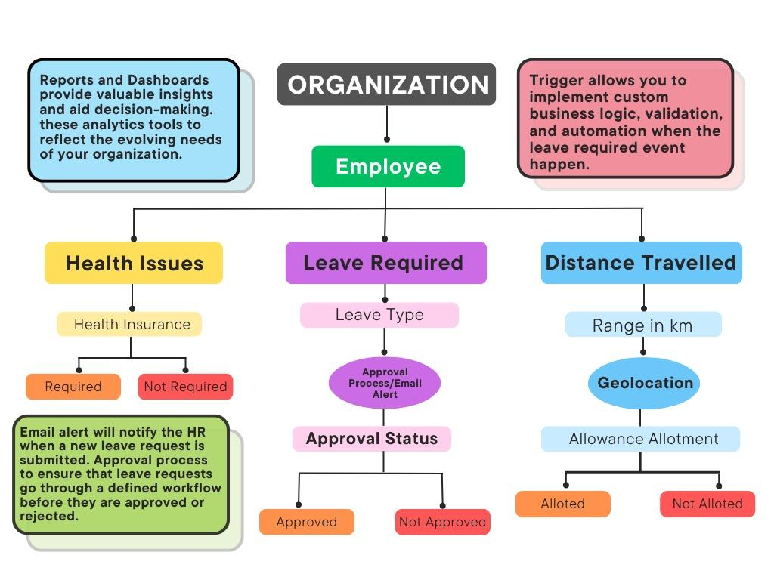efinition**

|  |  |  |  |
| --- | --- | --- | --- |
| **Problem for** | **Trying to** | **But** | **Which makes** |
| **HR Manager** | Trying to: Implement the Streamlined Employee Detail Management system to have a centralized, error-free, and efficient system for managing all employee-related information, from personal details to job roles. | **But: Currently, the organization lacks a digital system, relying heavily on manual processes and spreadsheets, leading to data redundancy, inaccuracies, and inefficiencies.** | **Which makes: The HR team spend unnecessary time on administrative tasks, potentially resulting in mismanagement and dissatisfaction among employees due to inconsistent data handling and delays.** |

* 1. **Empathy Map Canvas**

An empathy map is a simple, easy-to-digest visual that captures knowledge about a user’s behavior and attitudes.

1.5 proposed Solution



|  |  |  |
| --- | --- | --- |
| **S. No** | **Parameter** | **Description** |
| 1. | Problem Statement | The problem to be addressed is the inefficient, disorganized, and manual management of employee details, leading to administrative overhead, potential data discrepancies, and security concerns. |
| 2. | Idea / Solution Description | The proposed solution is to develop a comprehensive Employee Detail Management System (EDMS) leveraging a platform like Salesforce. This system will have custom modules for capturing various aspects of an employee's profile, from personal and contact details to job roles and performance metrics. Features such as automated data validation, role-based access control, and integration with other HR tools will ensure data integrity, security, and a streamlined user experience. |
| 3. | Novelty / Uniqueness | The system's uniqueness comes from its role-based customization, ensuring managers, HR personnel, and employees access only relevant information. With real-time data syncing, automated alerts for milestones like work anniversaries or document expiry, and integration capabilities with other HR tools, the EDMS offers a comprehensive solution tailored for modern organizations. esign the data model with relationships between objects to enable efficient data management, allowing |

* 1. **Functional & Technical Requirements**
     1. Functional Requirements

|  |  |
| --- | --- |
| **Requirement** | **Description** |
| **Custom Object Creation** | Employee Data Management  Create custom objects for "Full-Time Employees," "Part-Time Employees," "Consultants," and "Interns" to manage detailed information, job history, and other relevant records. |
| **User Profiles and Roles** | Set up user profiles and roles to control access and permissions for different user groups, including "HR Manager," "Team Lead," and "General Employee."" |
| **Automation** | Implement automation using triggers, flows, and approval processes to automate employee onboarding, data validation, promotions, and record updates. |
| **Reports and Dashboards** | Develop various report types, including tabular, summary, and matrix reports, to provide insights into employee performance, training, and department metrics. Create dashboards for data visualization and analytics. |
| **Data Modeling** | Design the data model with relationships between objects to facilitate efficient management of employee details, performance reviews, and training records. |

* + 1. Technical Requirements

|  |  |
| --- | --- |
| **Requirement** | **Description** |
| **Salesforce Developer Org** | Create a Salesforce developer org for project development and testing. |
| **Lightning App** | Create a Lightning app to brand the application and provide a customized color scheme and logo. |
| **Automation Tools** | Use Apex triggers and flows to implement automation in the system. |
| **Security and Access Control** | Configure security settings using user profiles, roles, and sharing rules to control access to sensitive data. |
| **User Training** | Provide user training and documentation for effective adoption of the Salesforce system within the cosmetics store. |

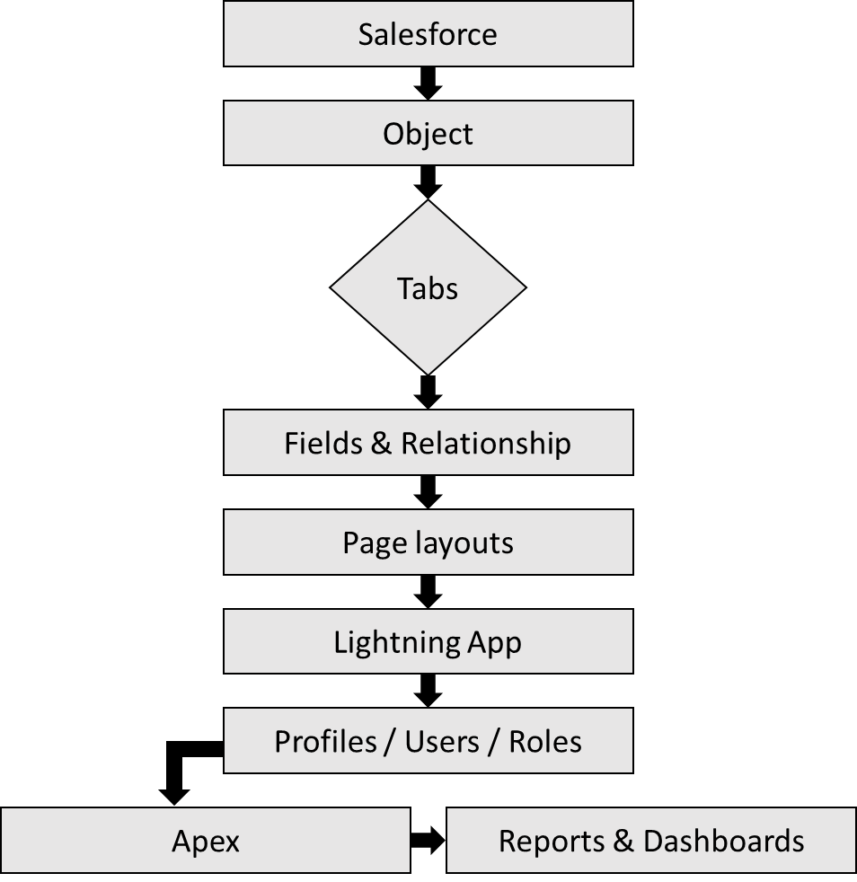**1.7 Project Road Map**

1.7.1 Technical Architecture

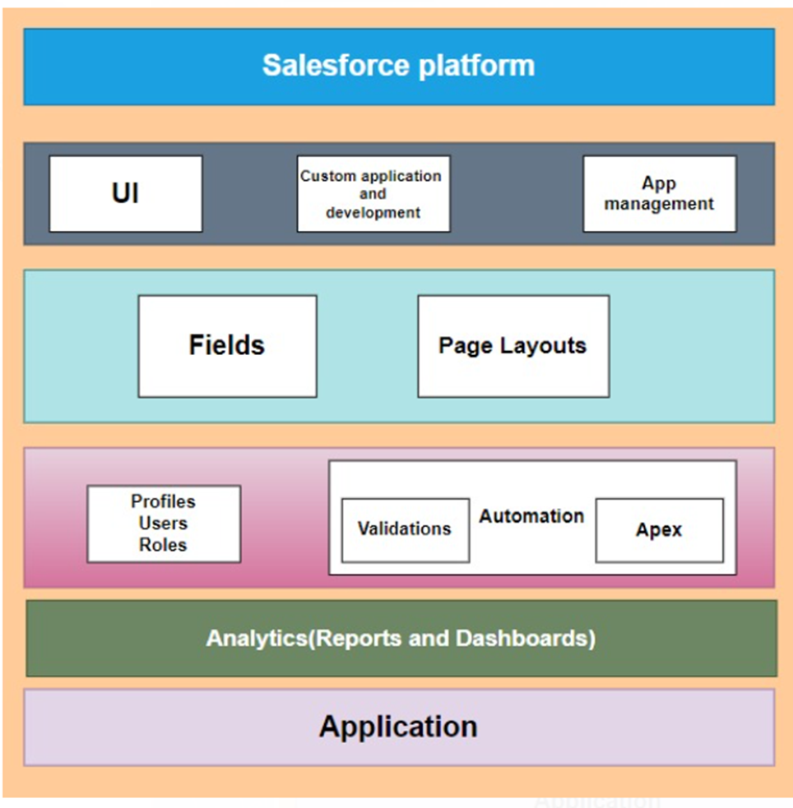1.7.2 Data Flow Diagram

A Data Flow Diagram (DFD) is a traditional visual representation of the

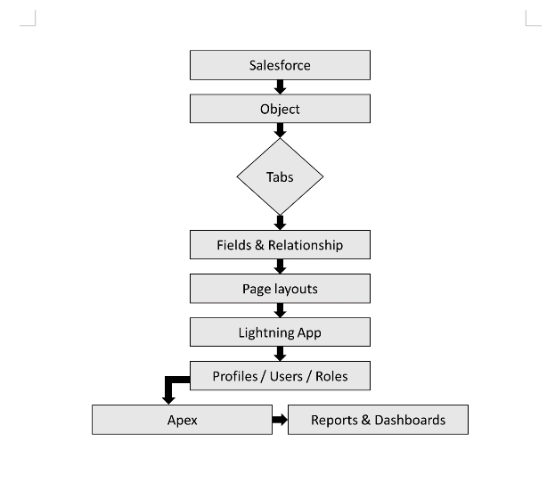

**CHAPTER-2**

**PREPARATION DATA MODELING**

**2.1 Salesforce Developer Org**

In Salesforce, a Developer Sign Up or Developer Edition is a special type of Salesforce environment that is primarily used for development, testing, and learning purposes.

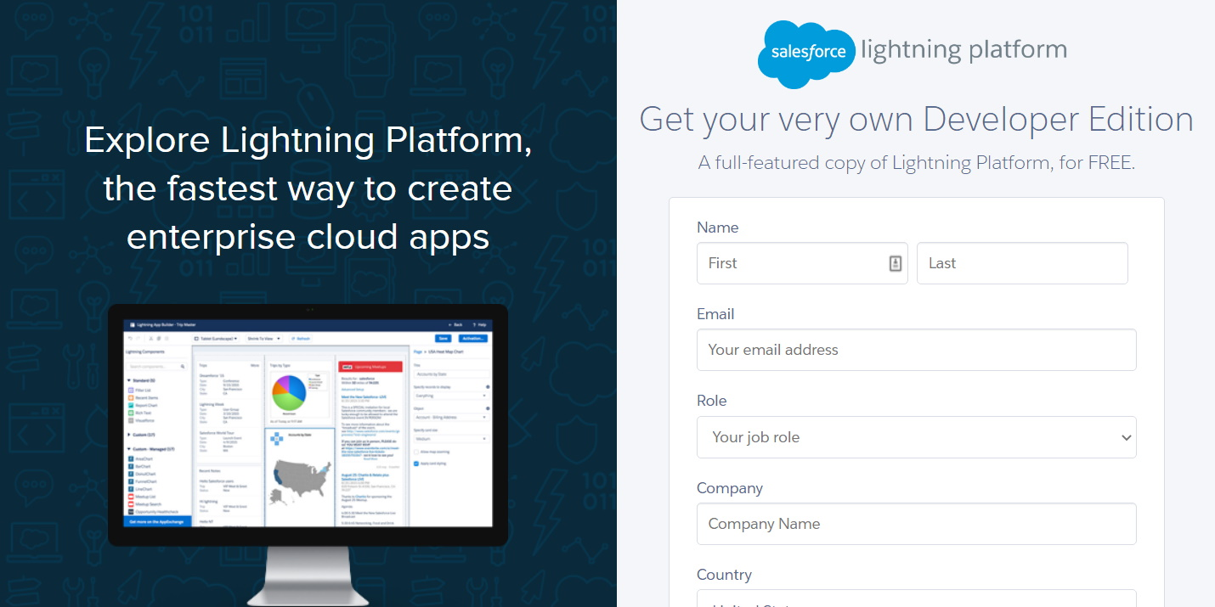

**Account Activation** 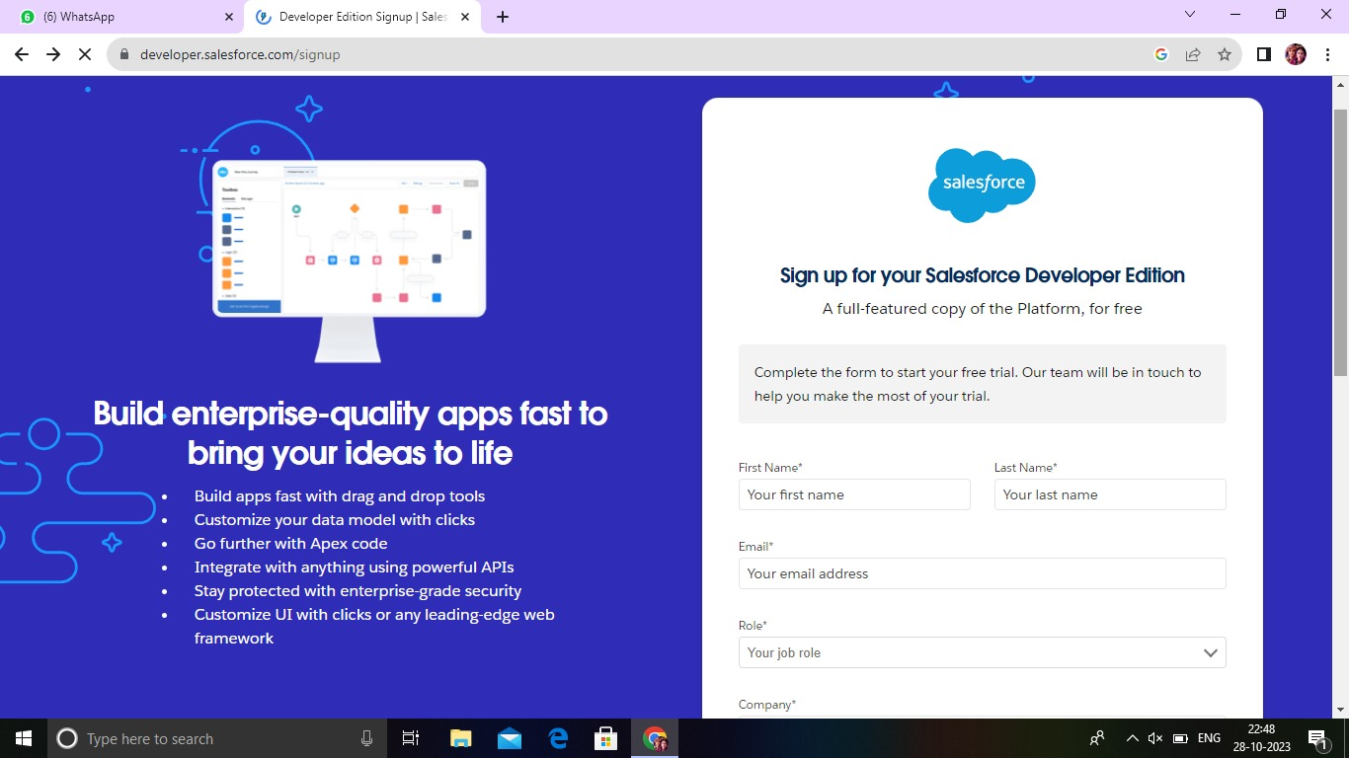

Activation tracks information about devices from which users have verified their identity.

**2.2 Object Creation**

Salesforce objects are database tables that permit you to store data that is specific to an organization. Salesforce objects are of two types: Standard Objects: Standard objects are the kind of objects that are provided by salesforce.com such as users, contracts, reports, dashboards, etc. Custom objects: Our_Customers, Consultants, Retailers, Others.

**Create the Consultants Object**

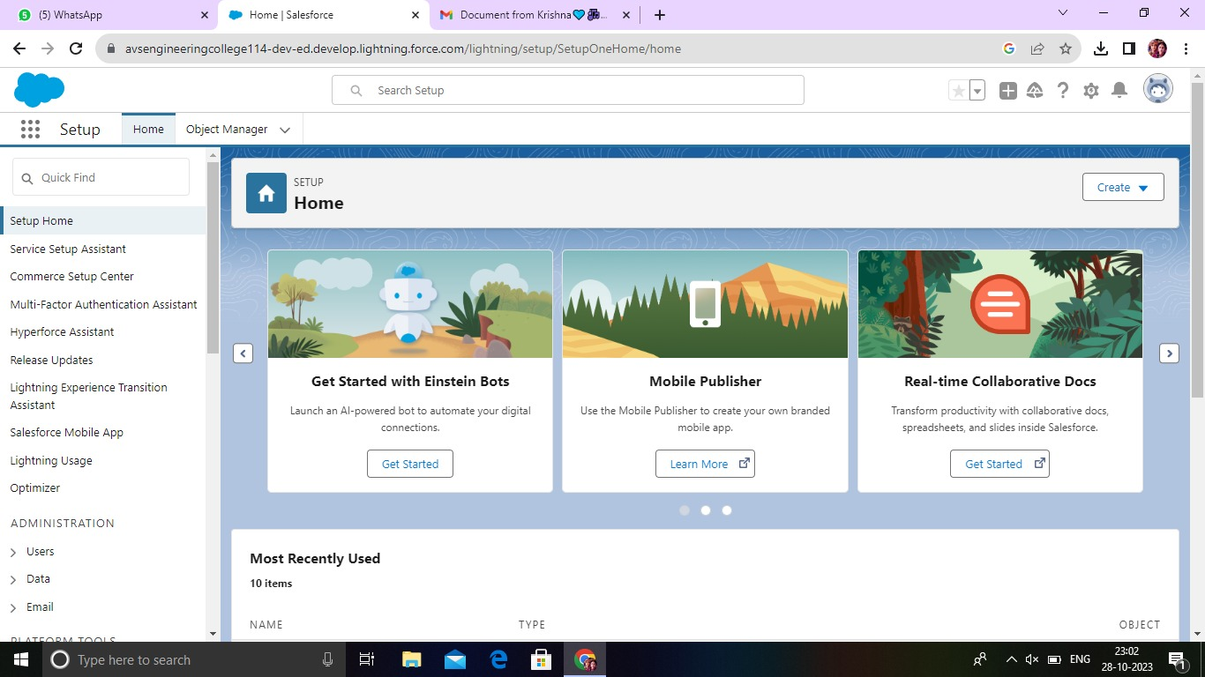

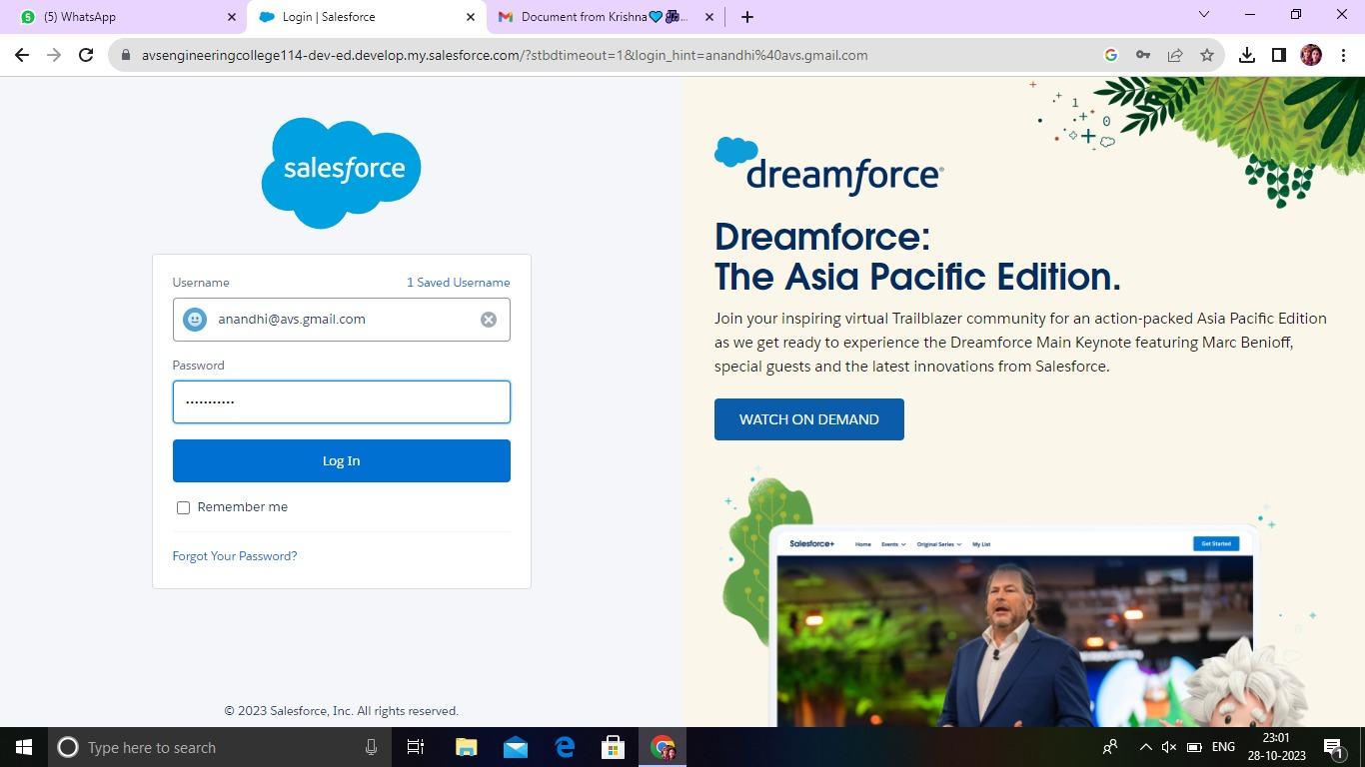

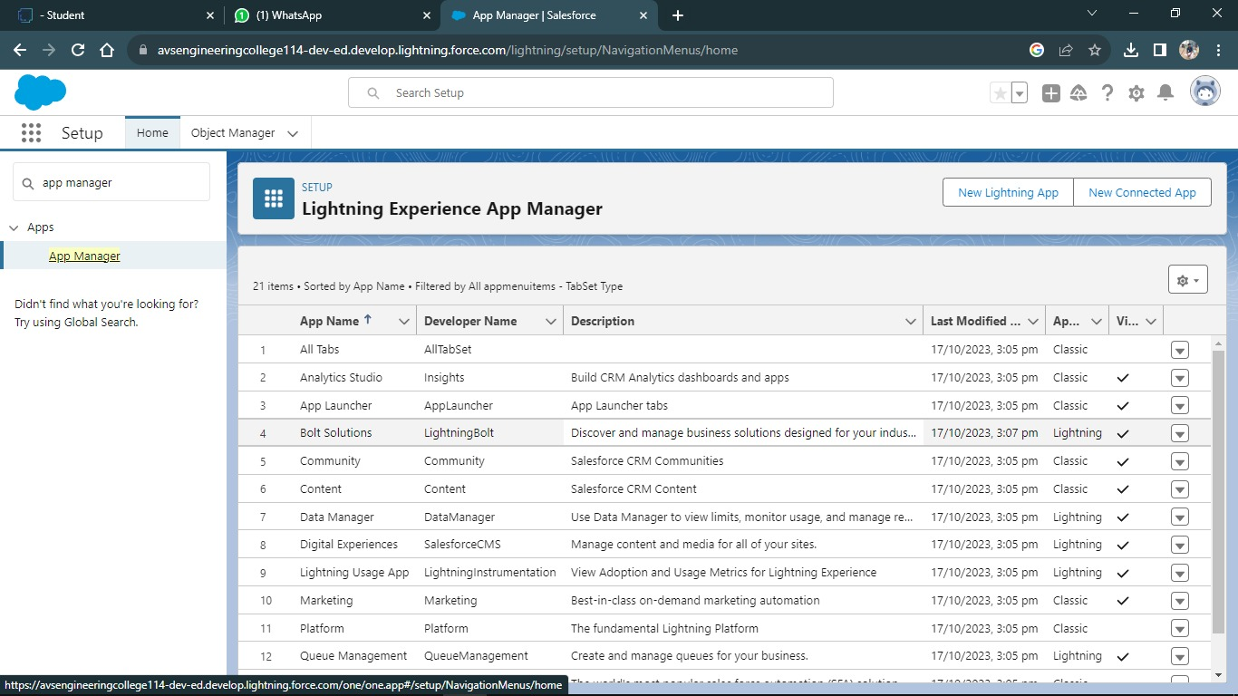

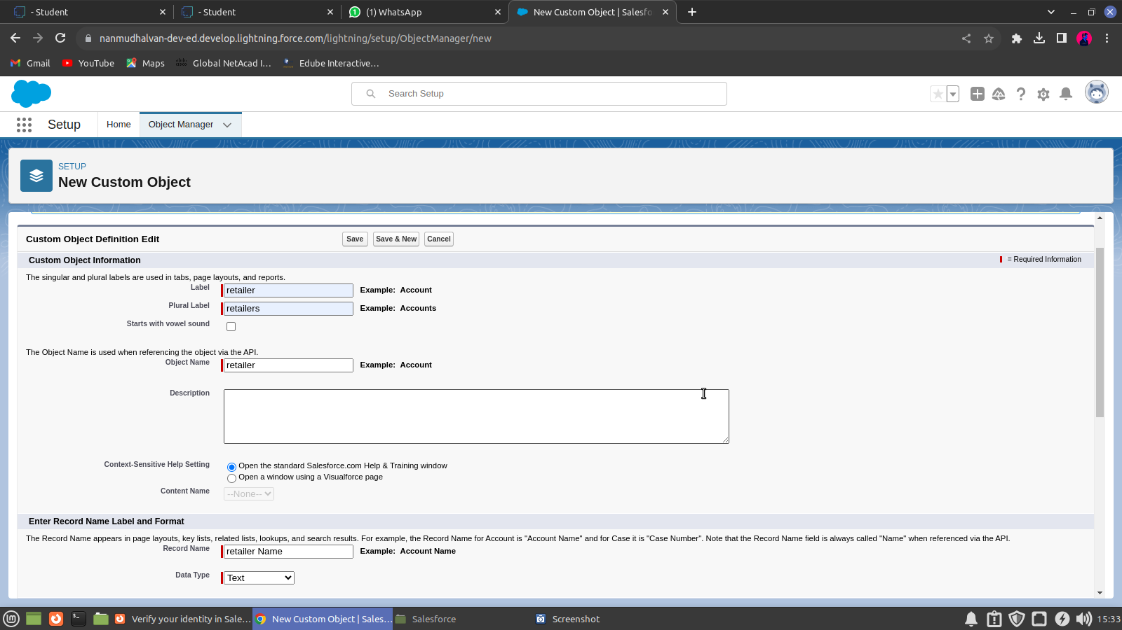

**Create the Others Object**

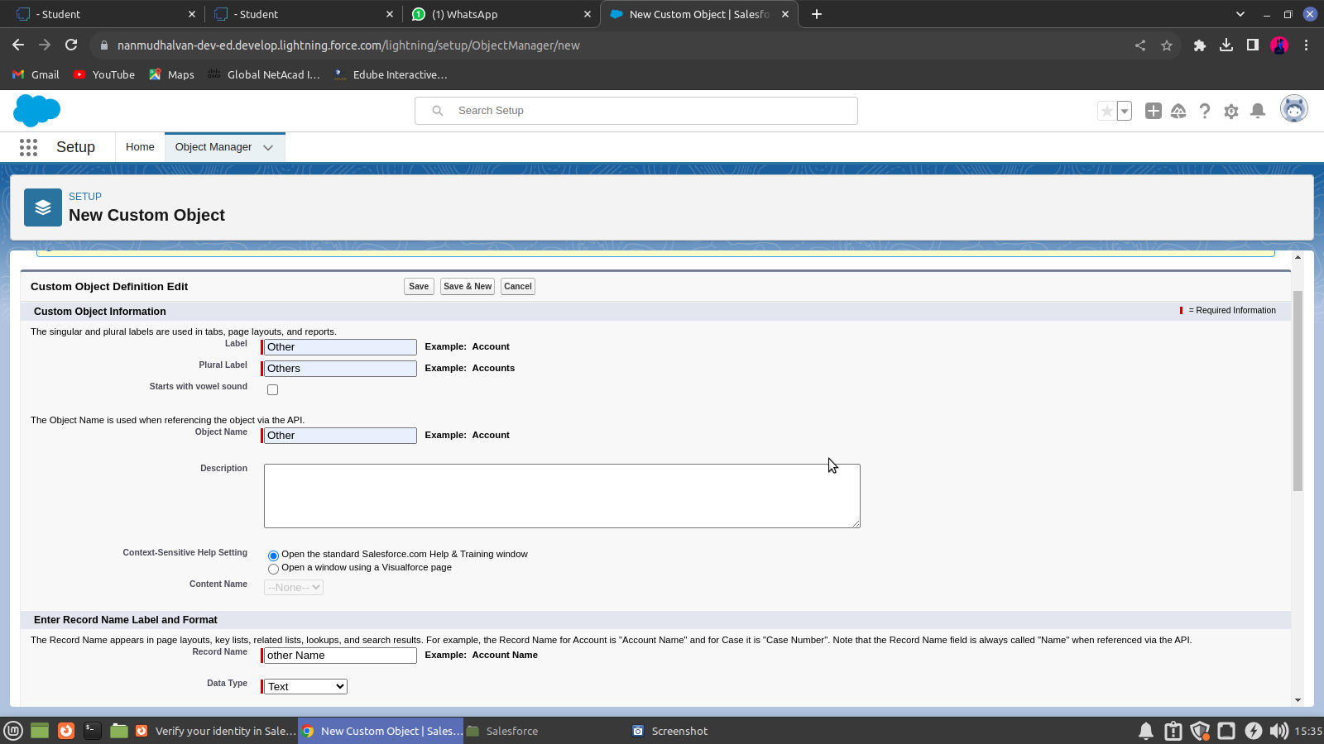

**2.3 Fields and Relationship**

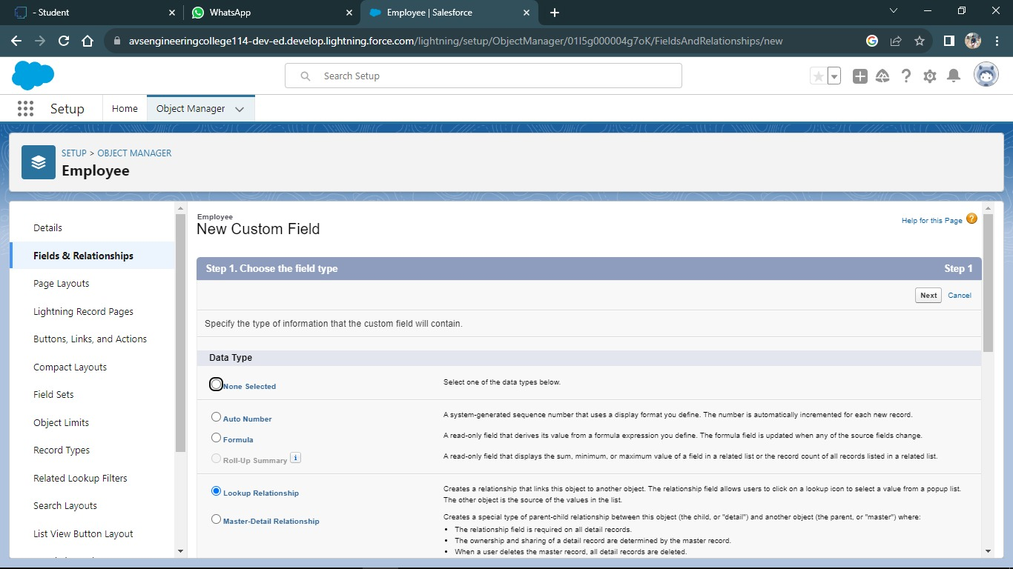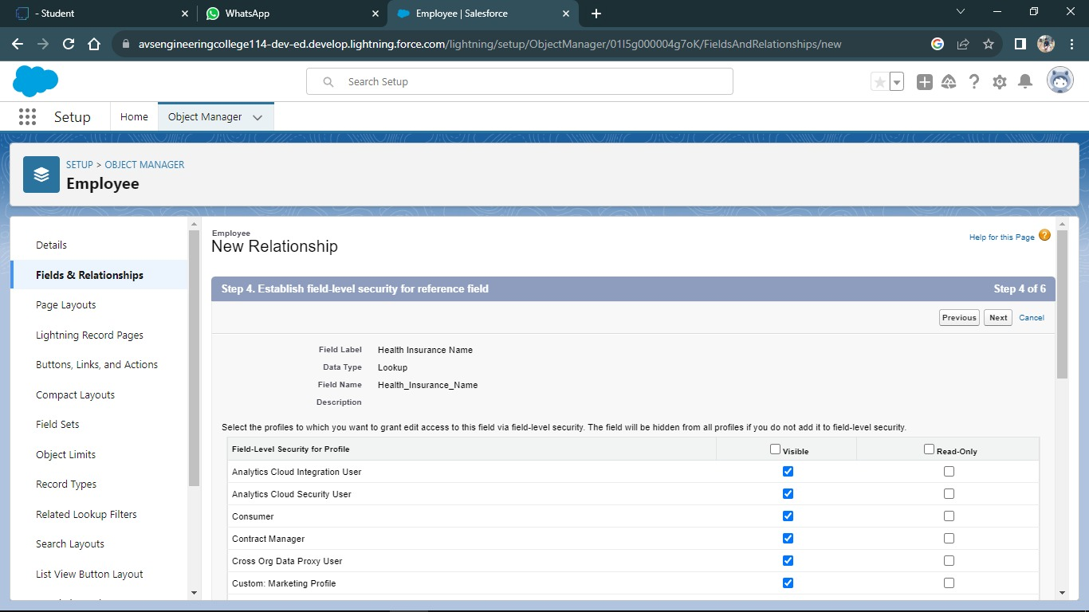

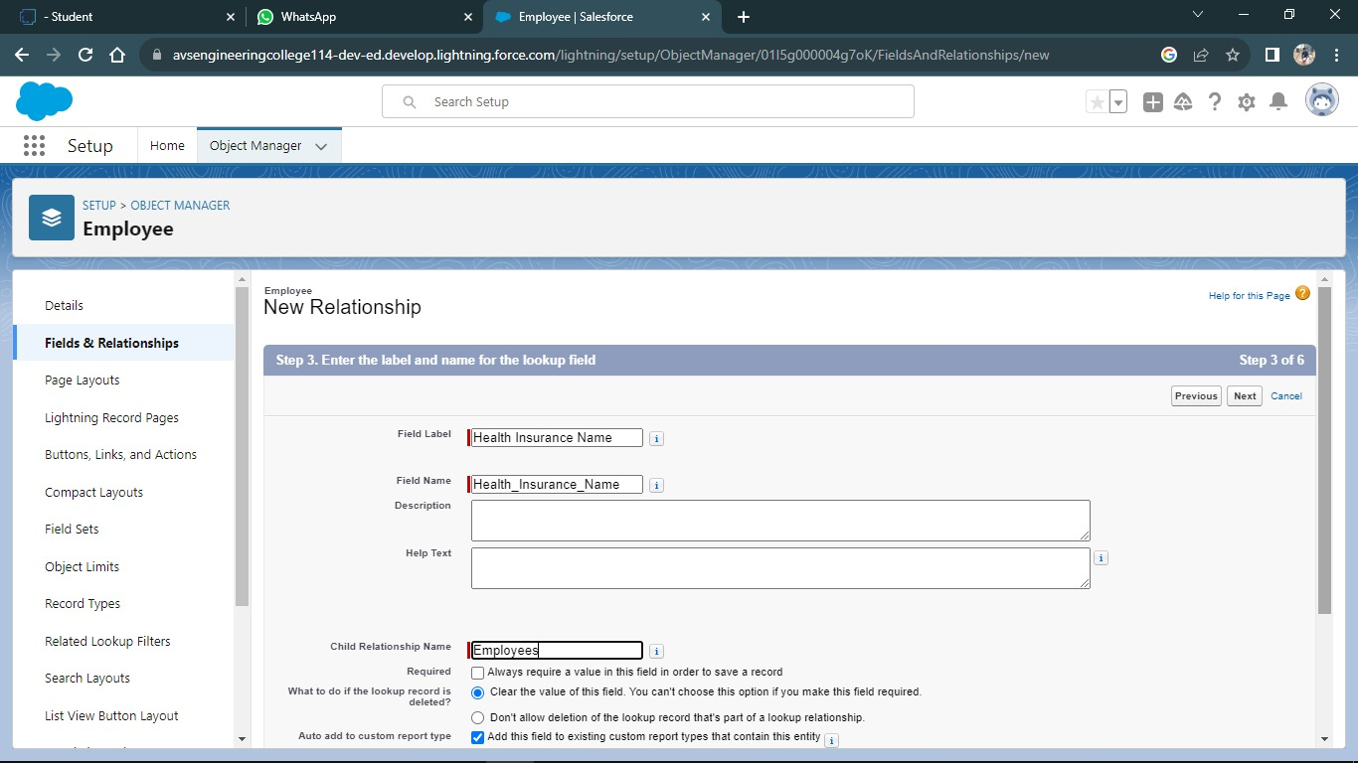

An object relationship in Salesforce is a two-way association between two objects. Relationships are created by creating custom relationship fields on an object. This is done so that when users view records, they can also see and access related data.

**Fields in Our_Customers Objects**

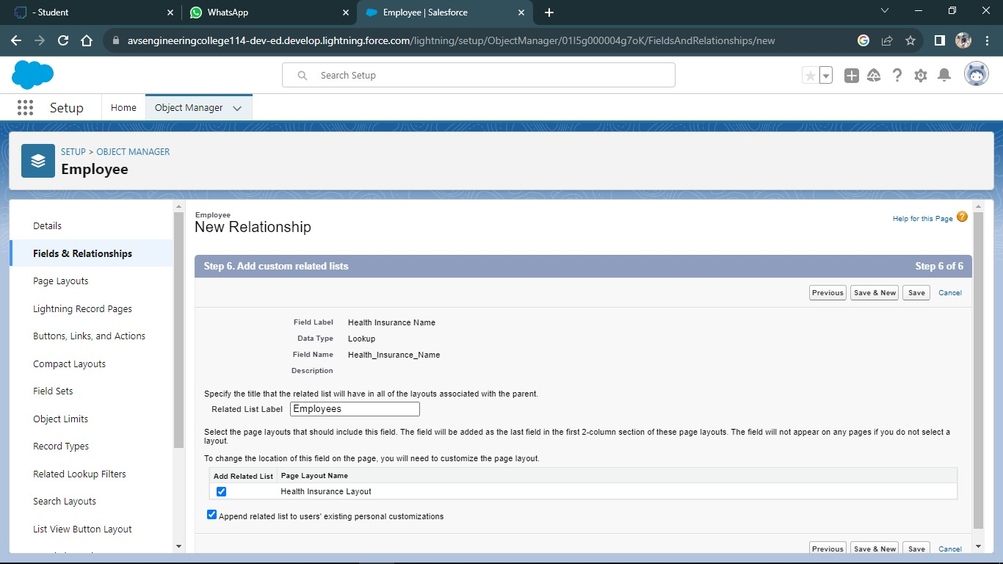

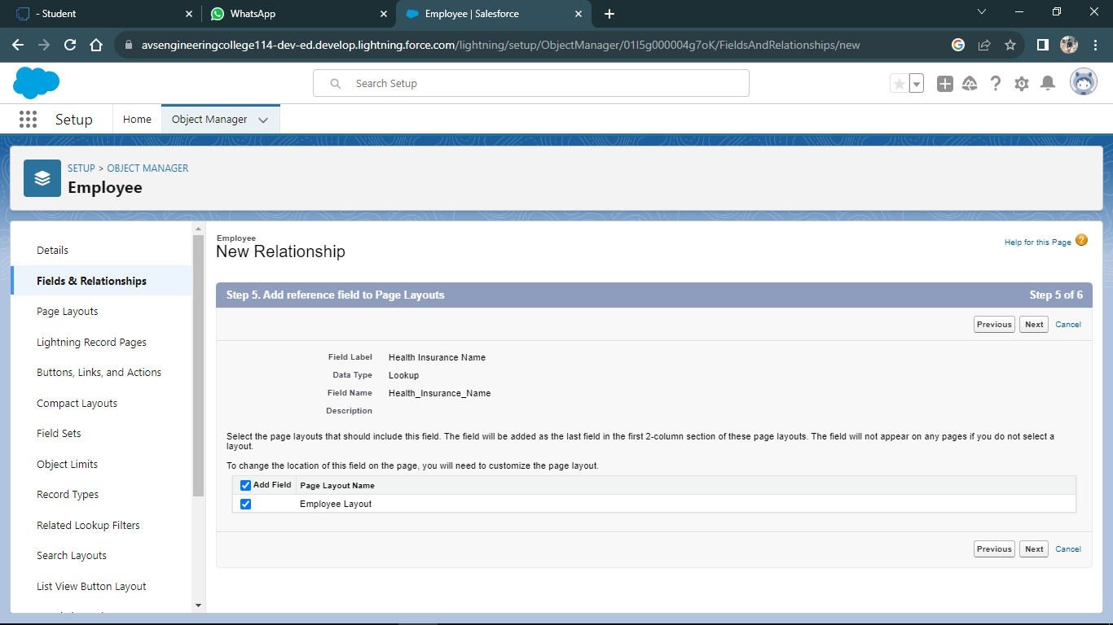

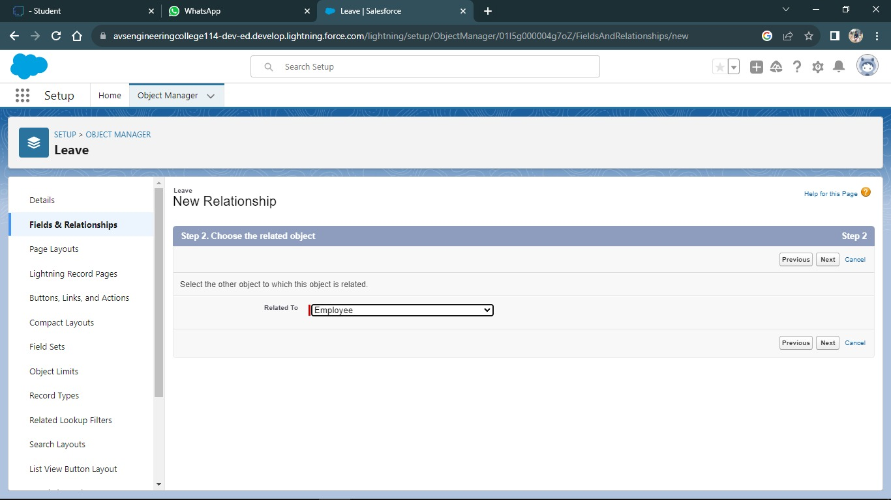

**Fields in Others Objects**

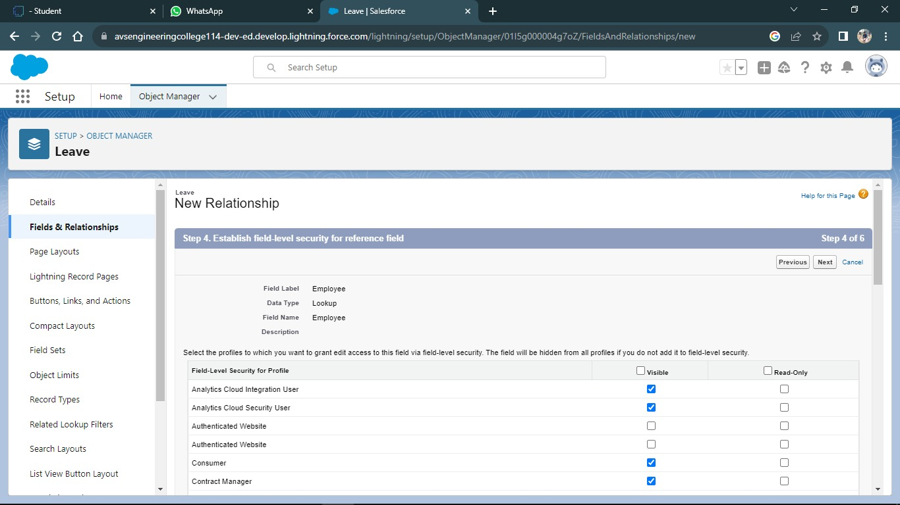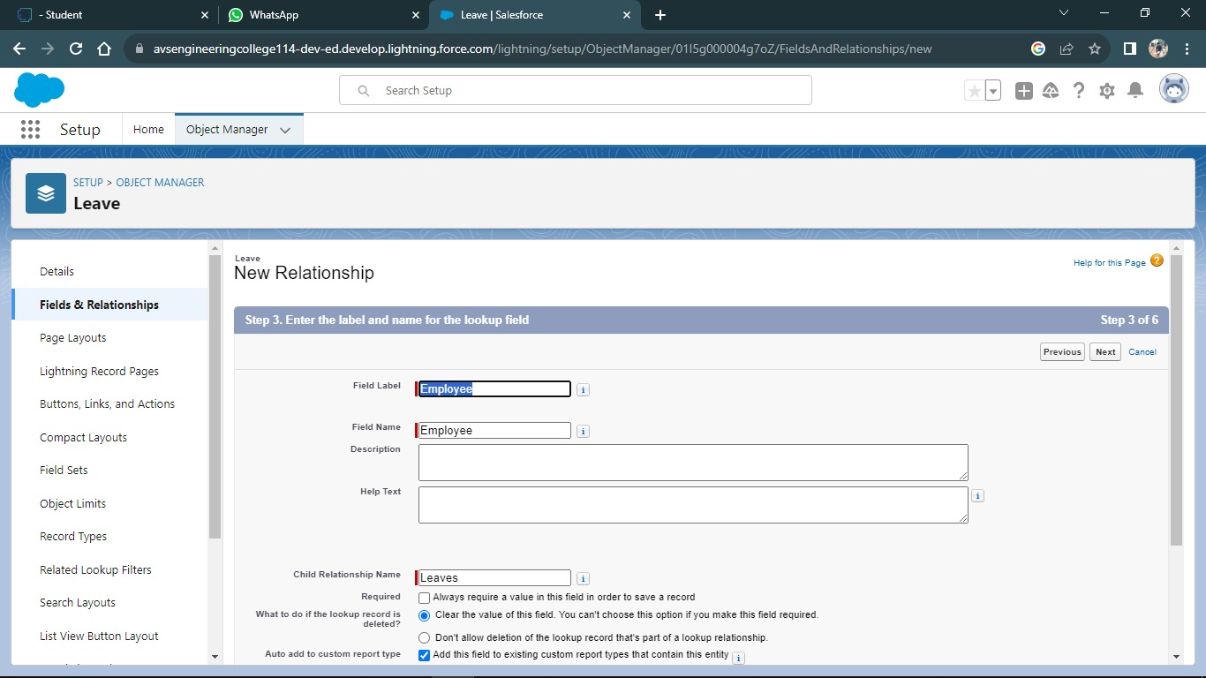

**2.4 Page Layouts**

In Salesforce, page layouts define the organization and arrangement of fields, buttons, related lists, and other components on an object's detail and edit pages. They allow you to control the user interface and tailor it to meet the specific needs of your organization.

**Select the Consultant Layout page layout**

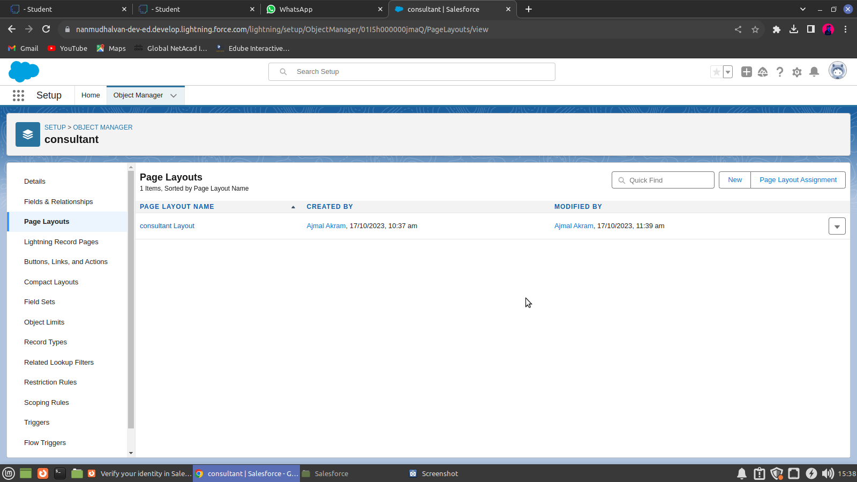

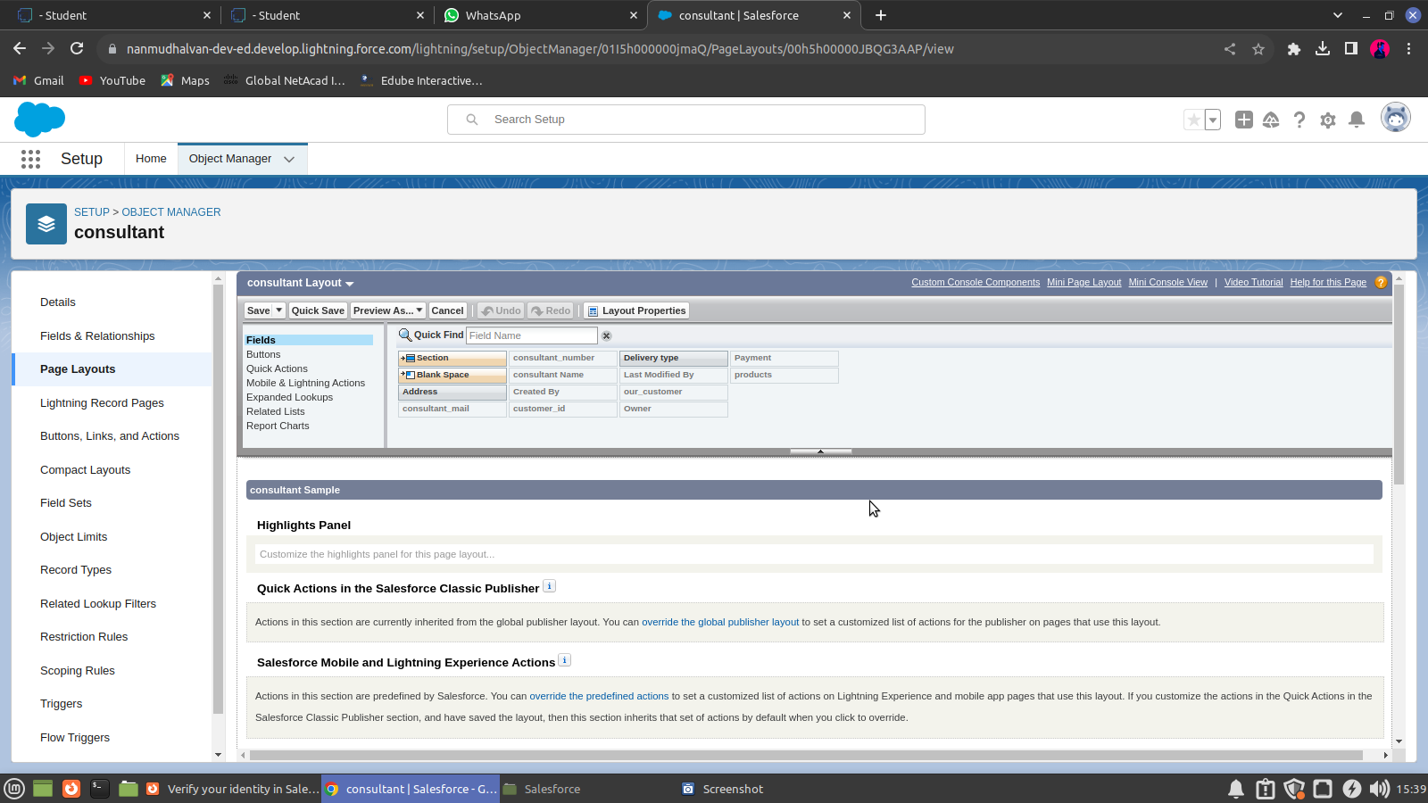

**2.5 The Lightning App**

An app is a collection of items that work together to serve a particular function. In Lightning Experience, Lightning apps give your users access to sets of objects, tabs, and other items all in one convenient bundle in the navigation bar. Lightning apps let you brand your apps with a custom Color and logo. You can even include a utility bar and Lightning page tabs in your Lightning app.

**To create a lightning app page**

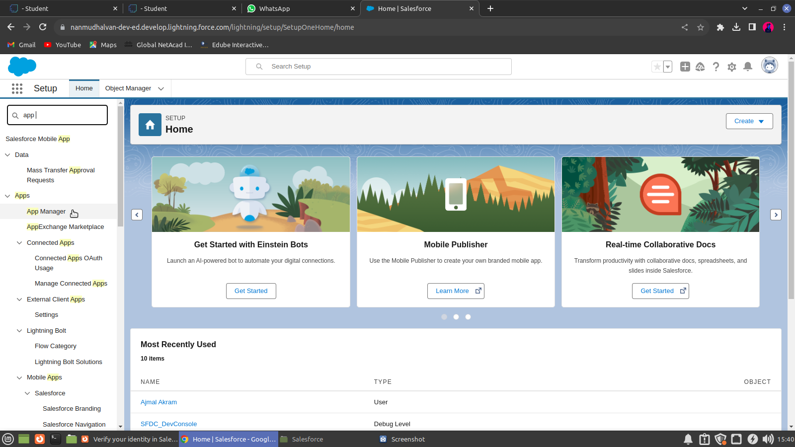



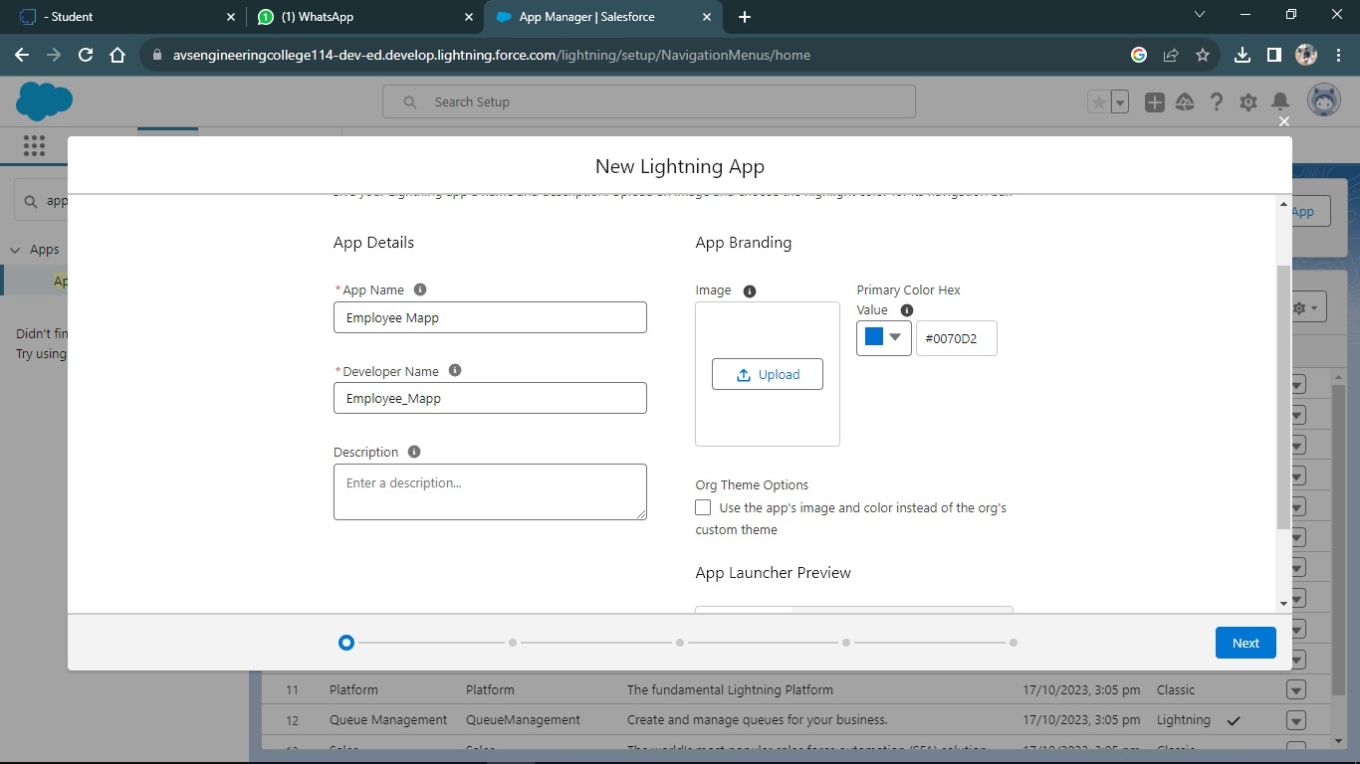

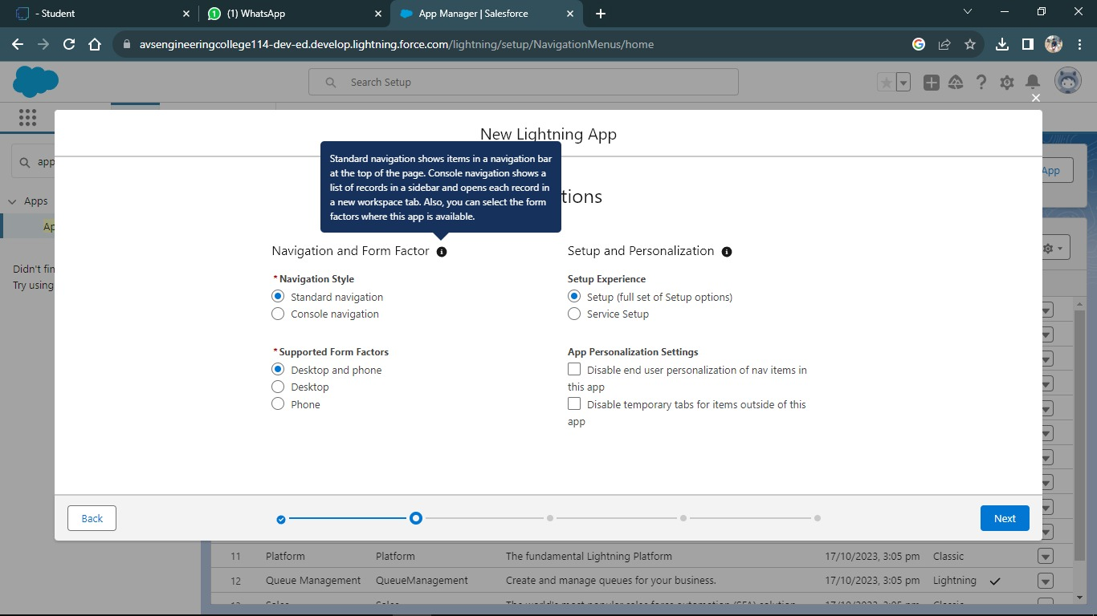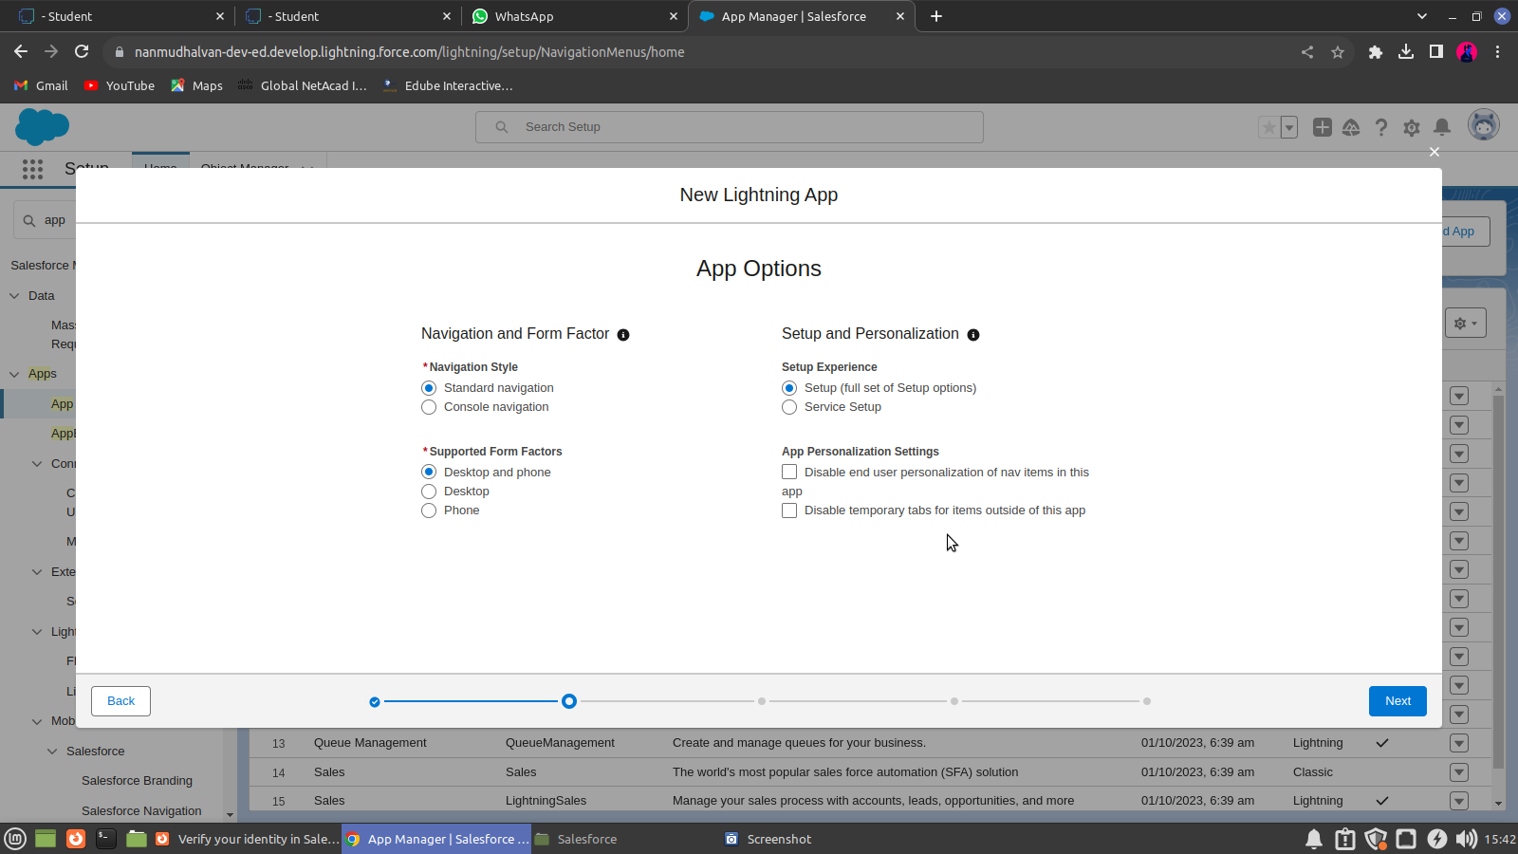

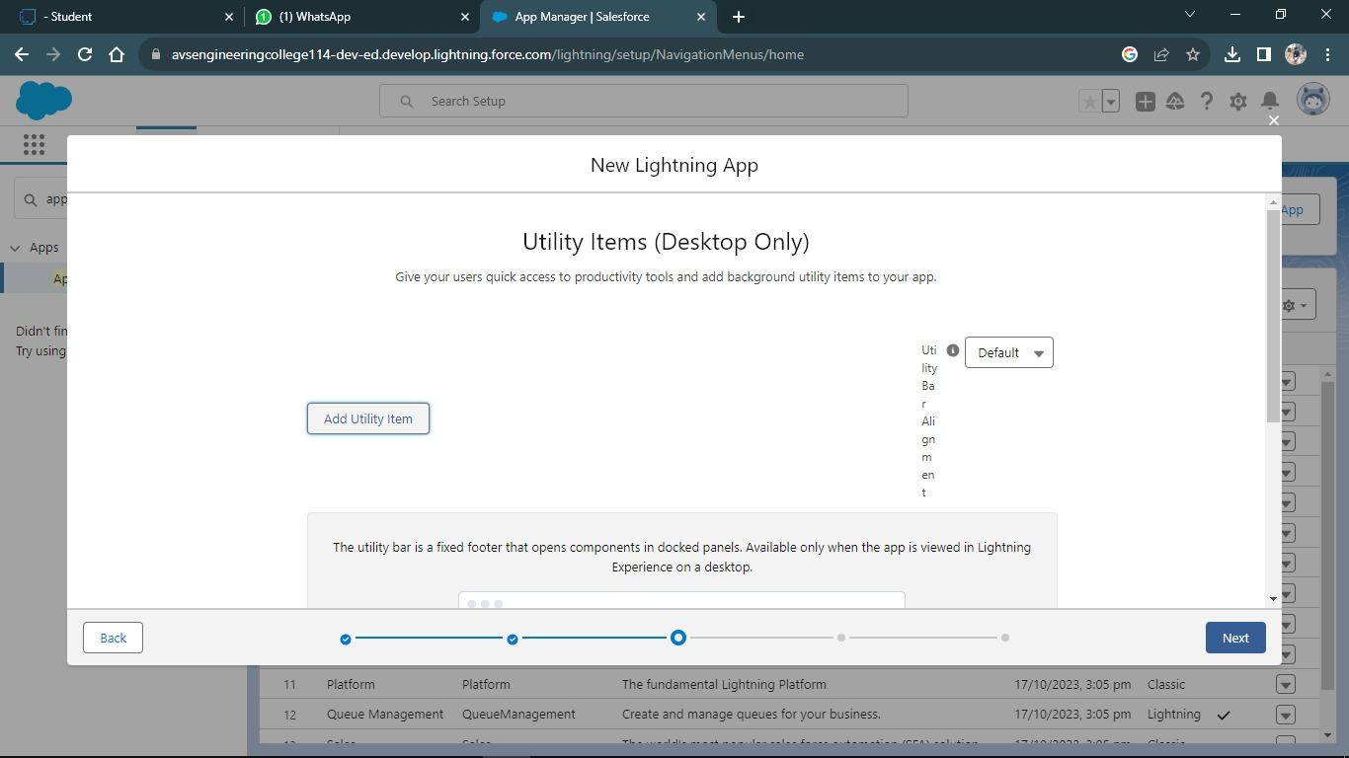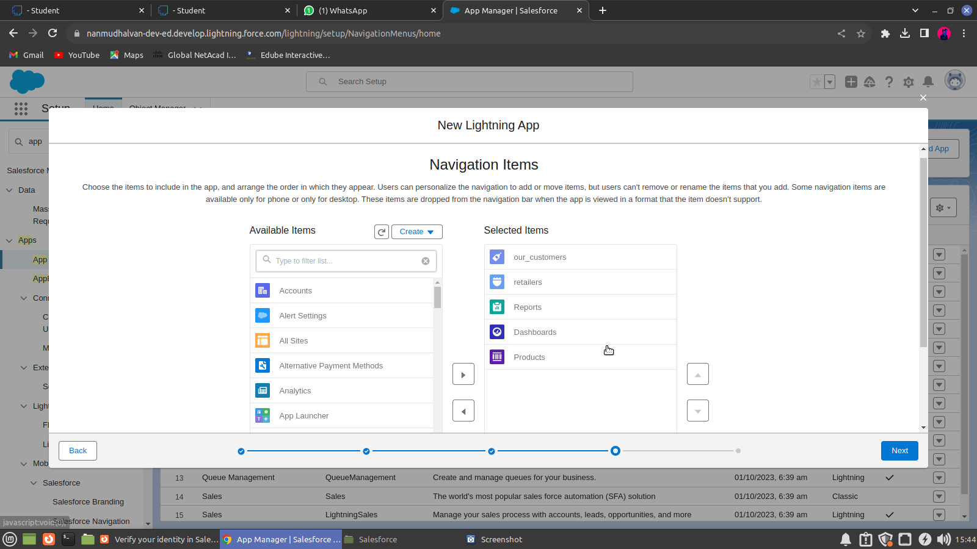

**CHAPTER-3**

**USERS & DATA SECURITY**

**3.1 Profile**

A profile is a group/collection of settings and permissions that define what a user can do in salesforce. A profile controls “Object permissions, Field permissions, User permissions, Tab settings, App settings, Apex class access, Visualforce page access, Page layouts, Record Types, Login hours & Login IP ranges.

**Creating a Profiles**

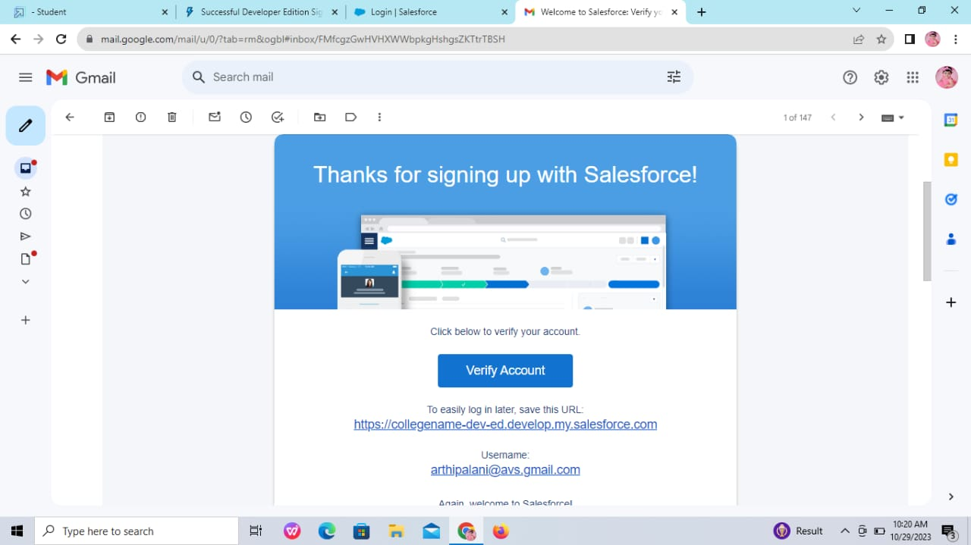

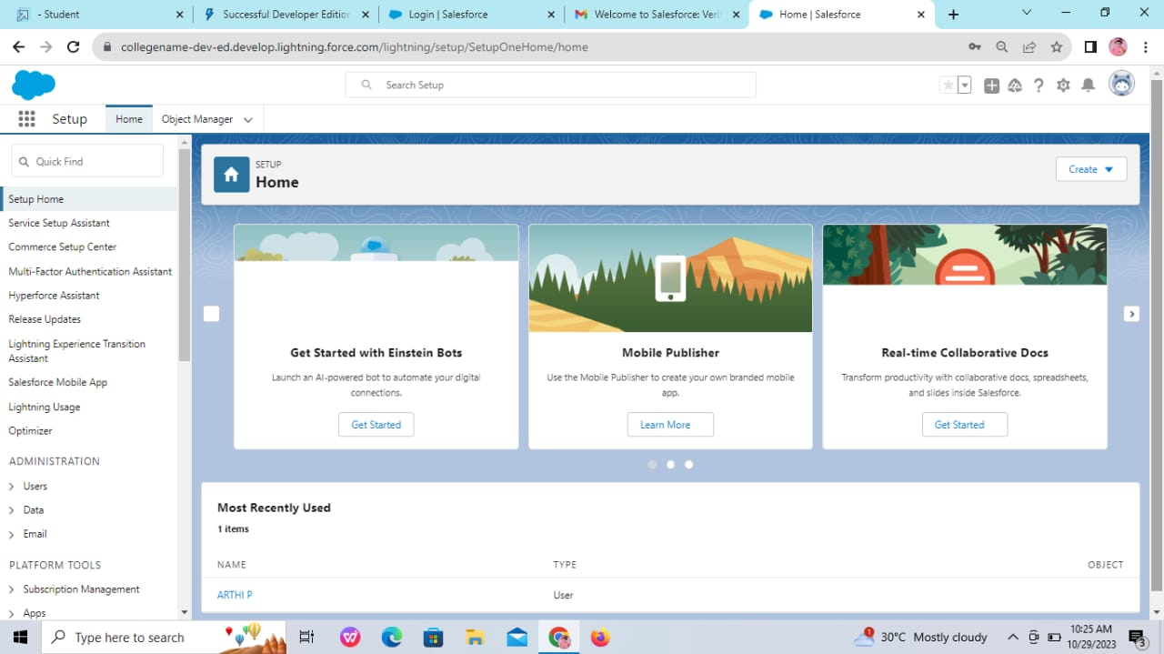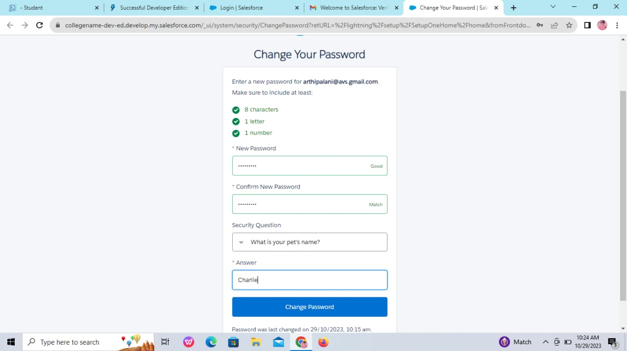

**To create a new profile (Store Supervisor)**

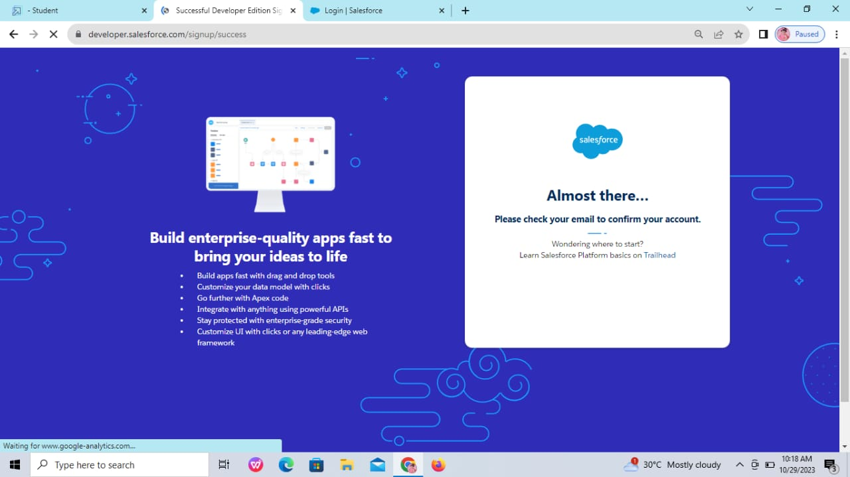

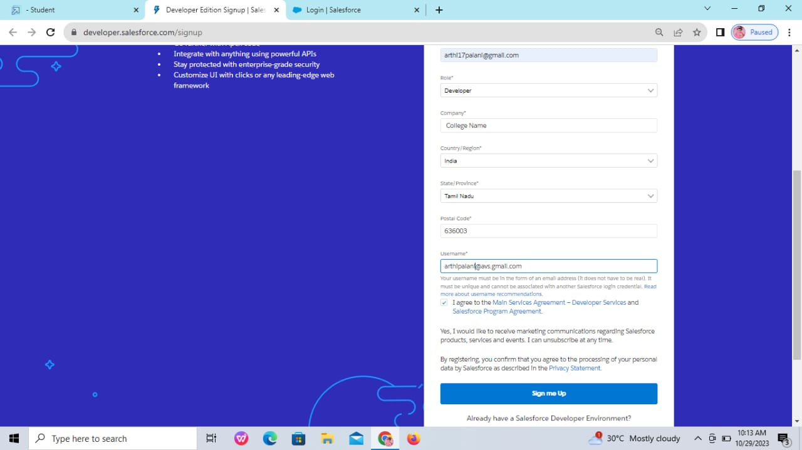

To create a new profile (Billing Operator)

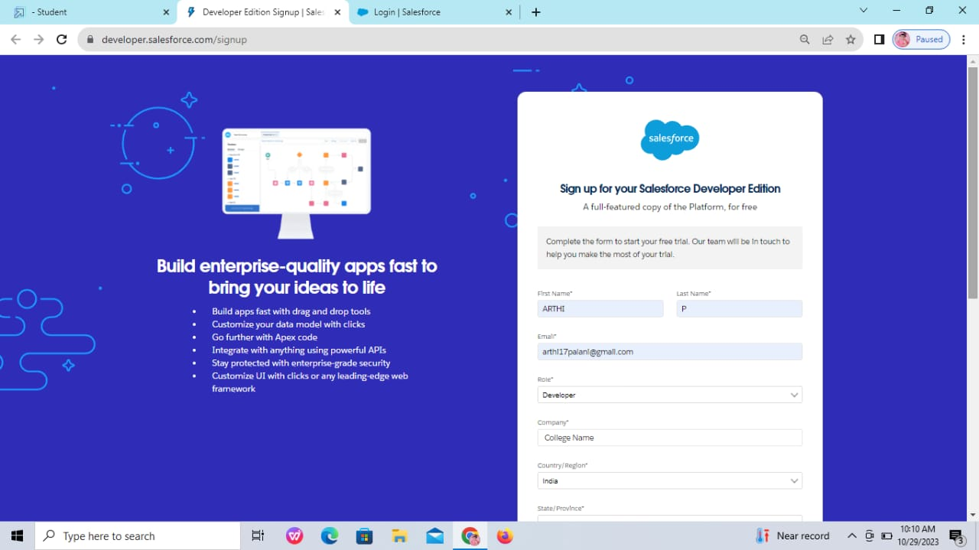

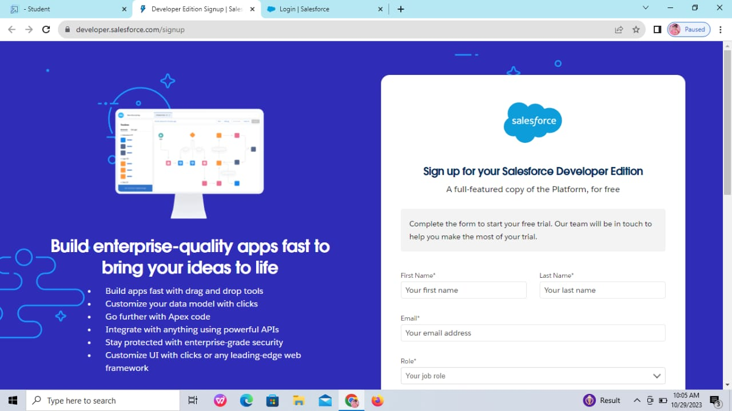

**3.2 Setup Roles**

Salesforce roles are record-level access controls that define what data a user can see in Salesforce.

**Creating a Role**

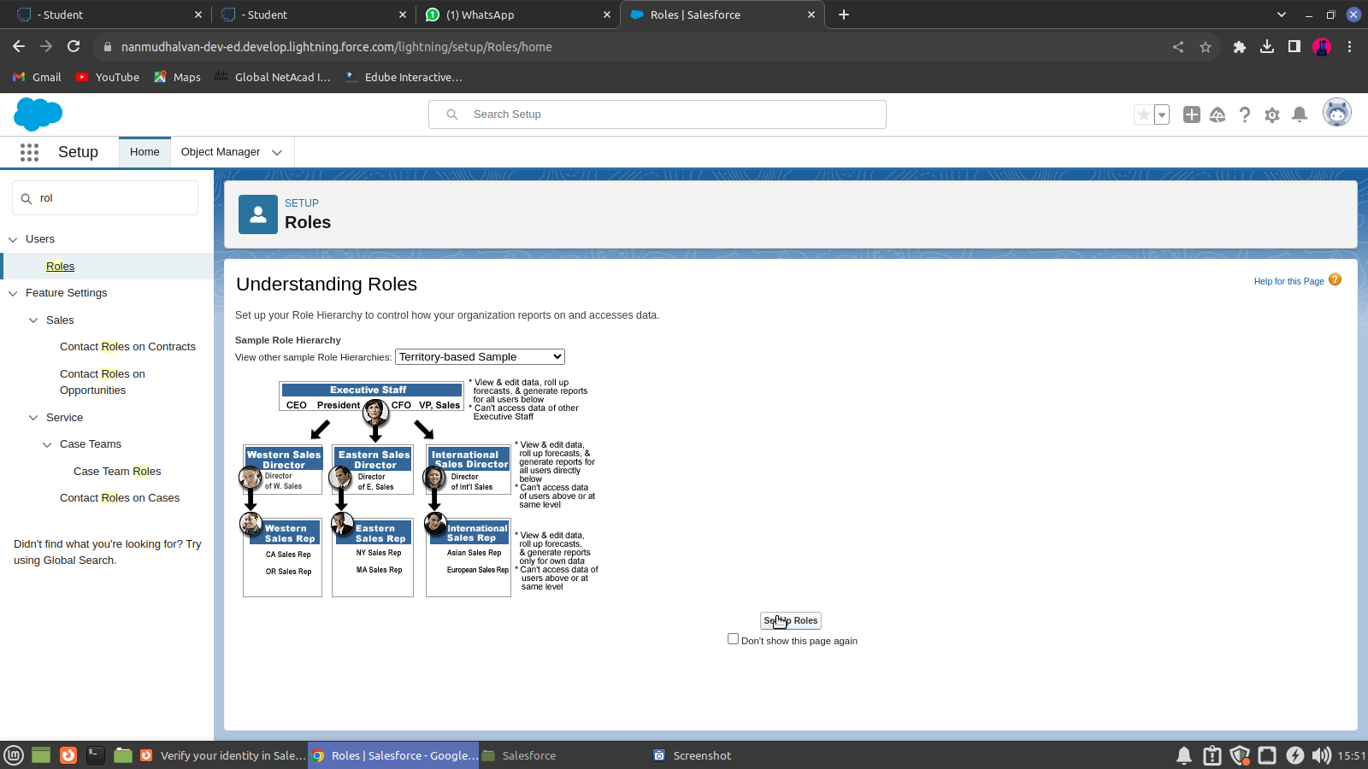

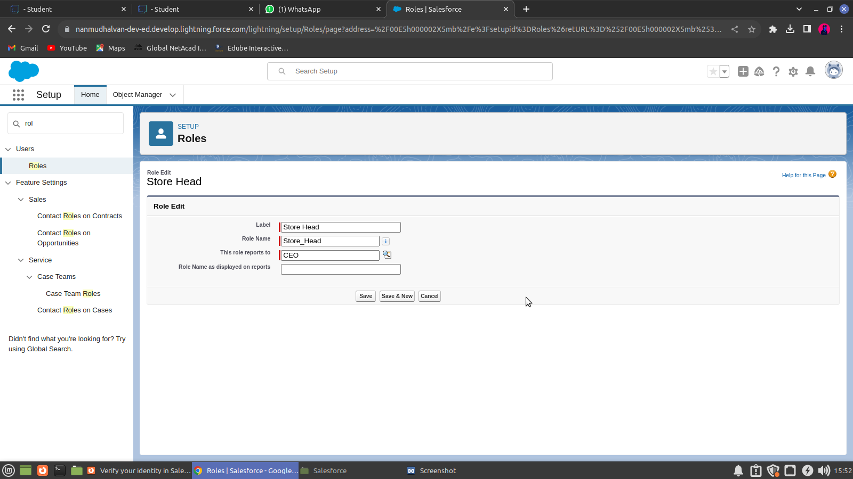

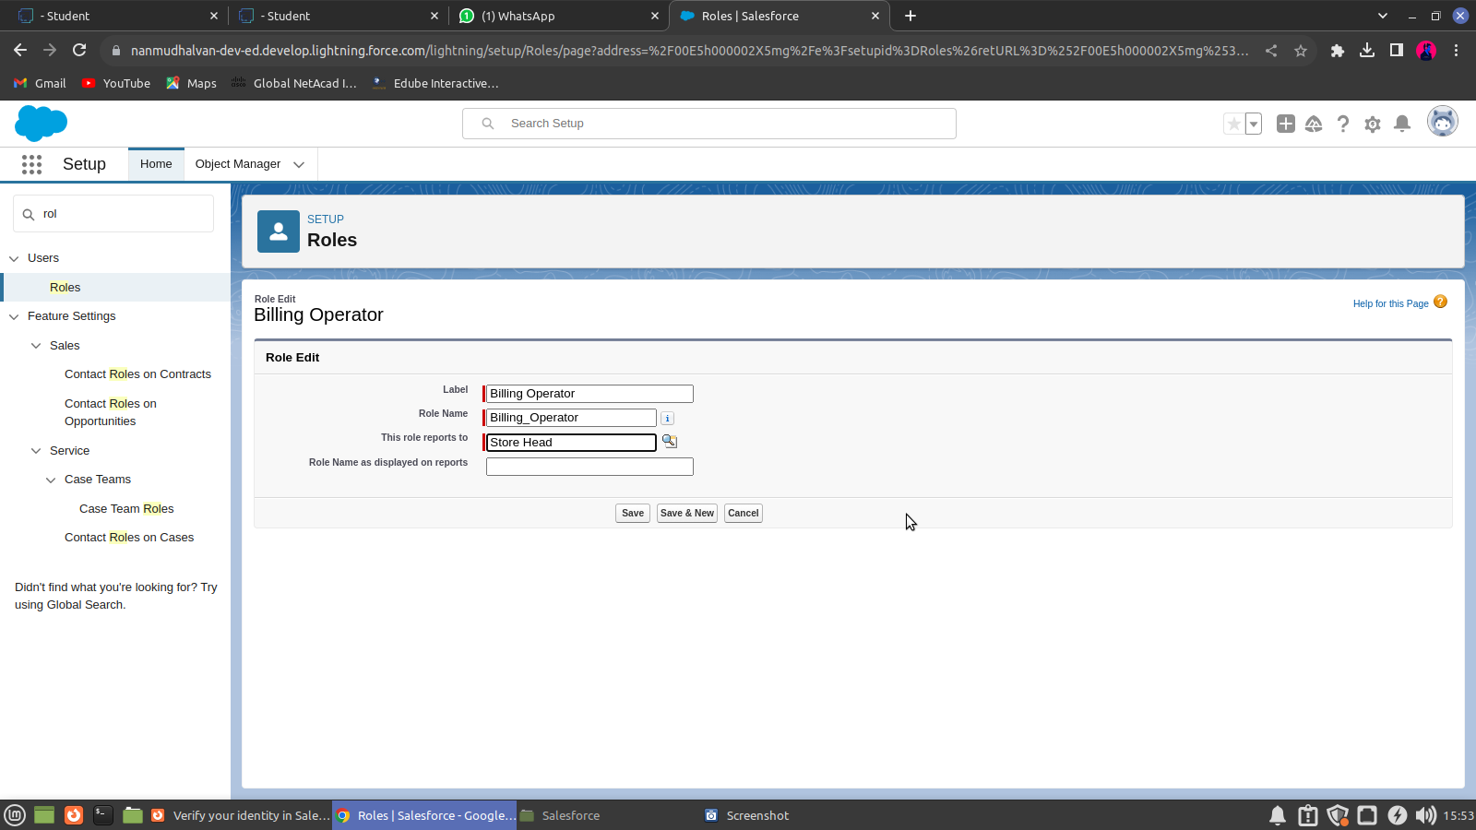

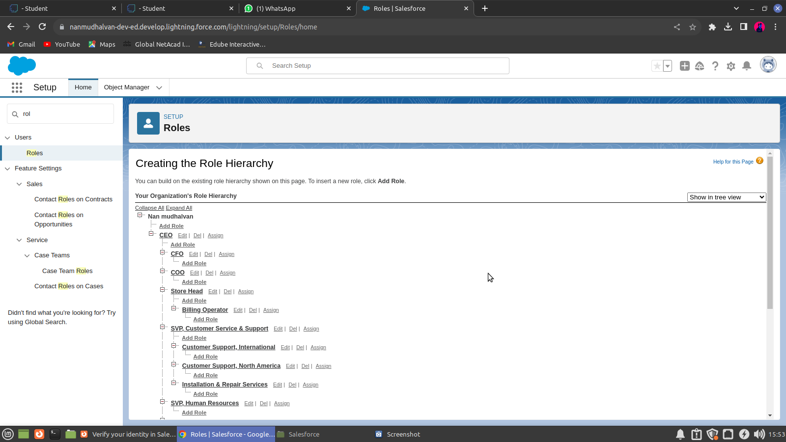

**3.3 Users**

GoodA user is anyone who logs in to Salesforce. Users are employees at your company, such as sales reps, managers, and IT specialists, who need access to the company's records. Every user in Salesforce has a user account.

**Creating A Users**

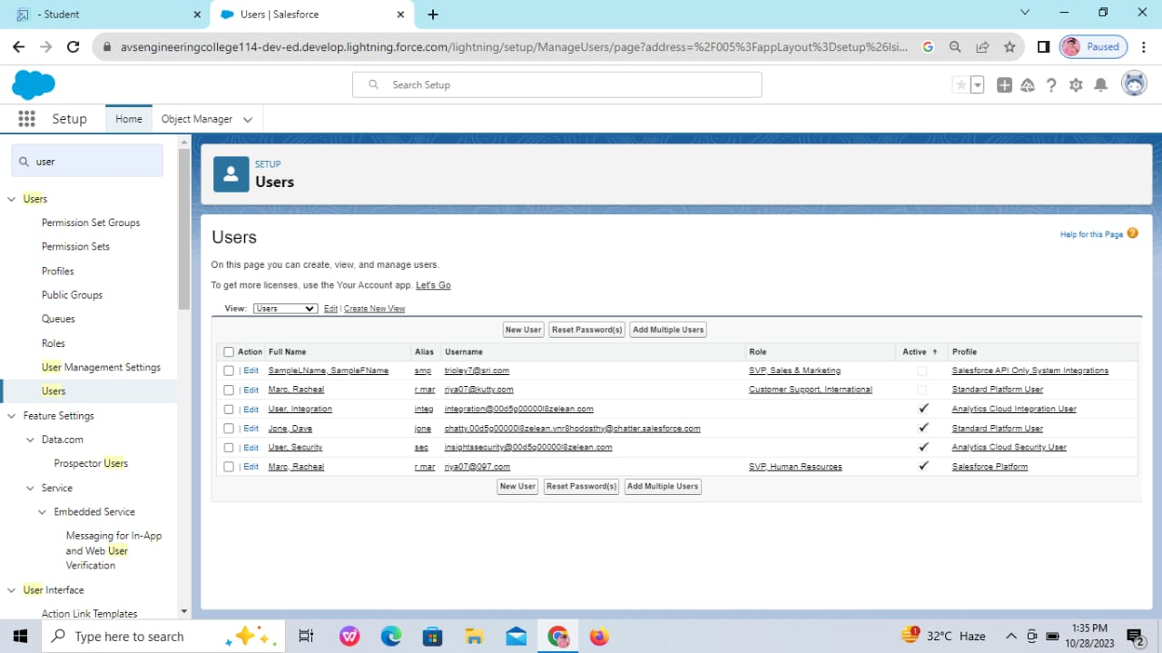

**Creating another Users**

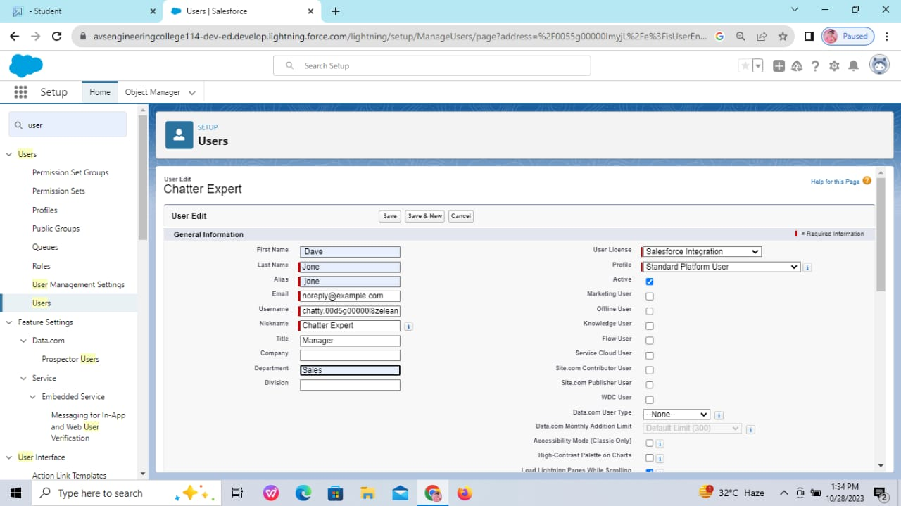

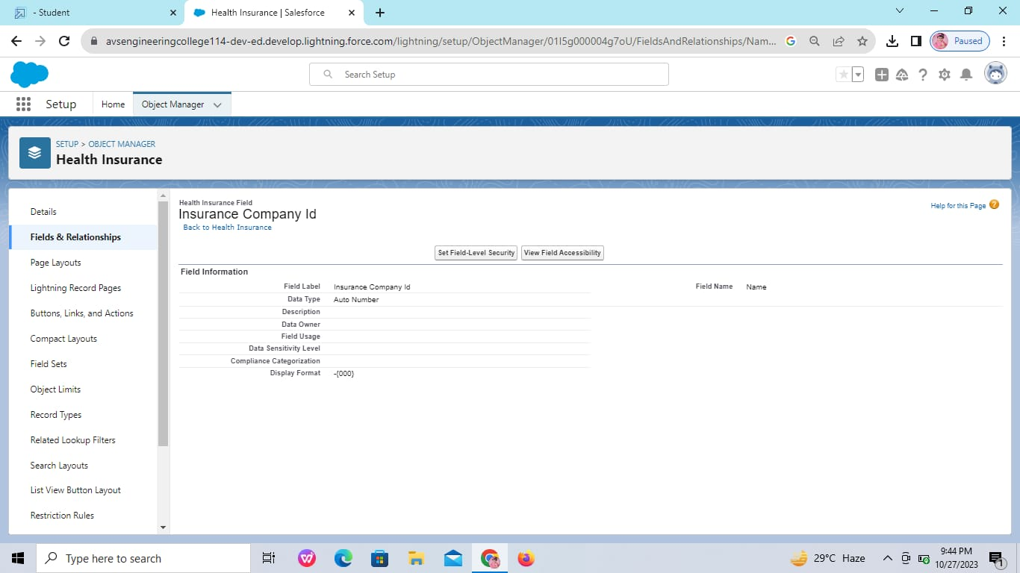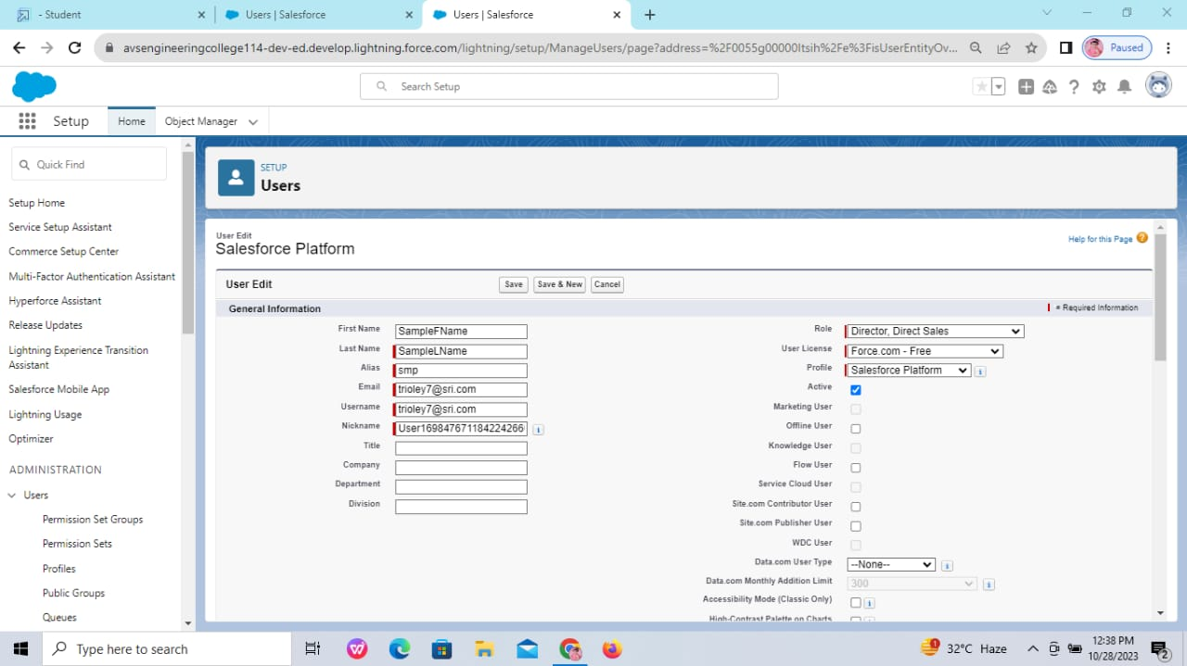

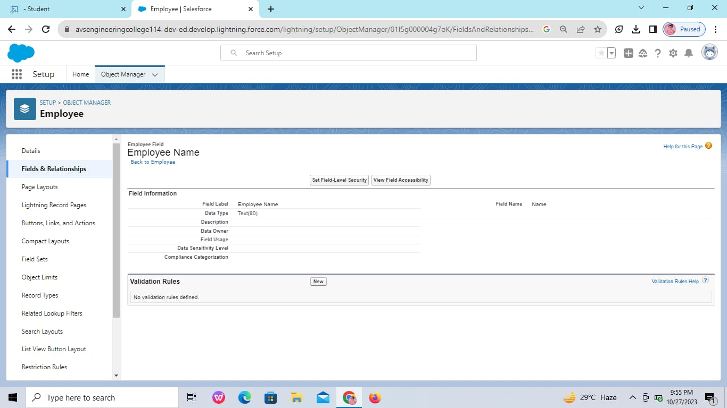

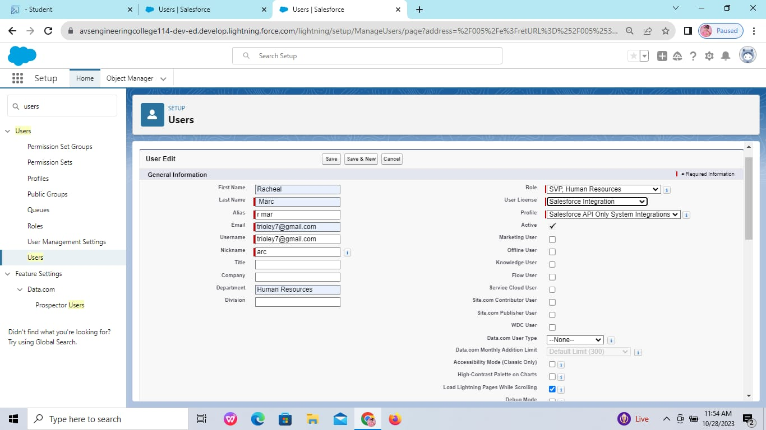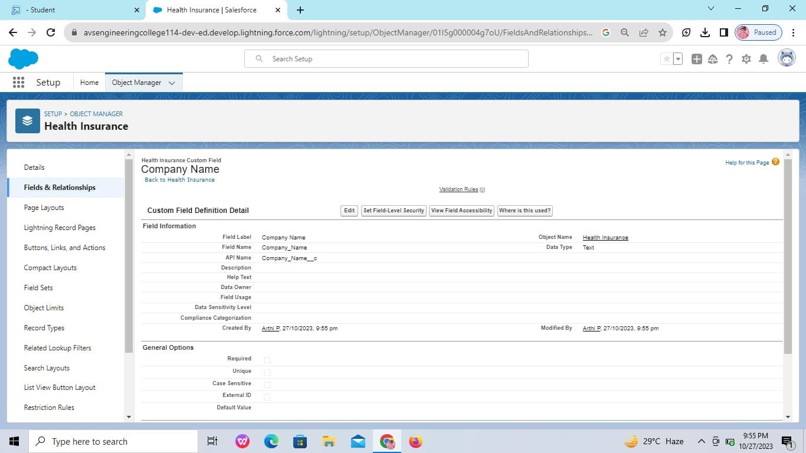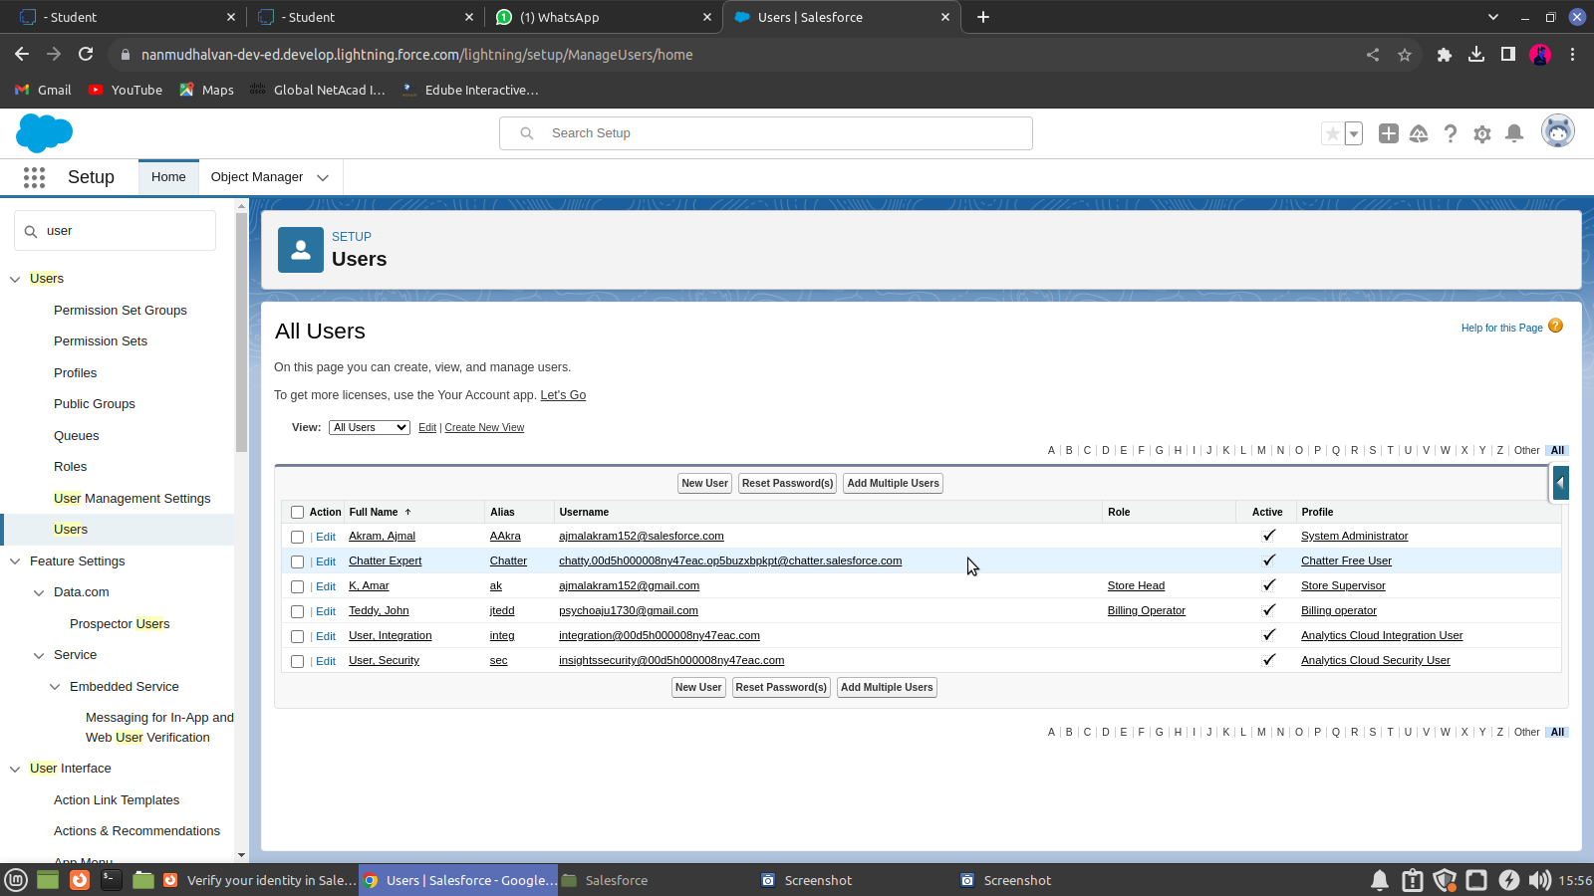

**3.4 User Adoption & Approval**

It is the interaction with database and their records.

**Create Our Customer Record**



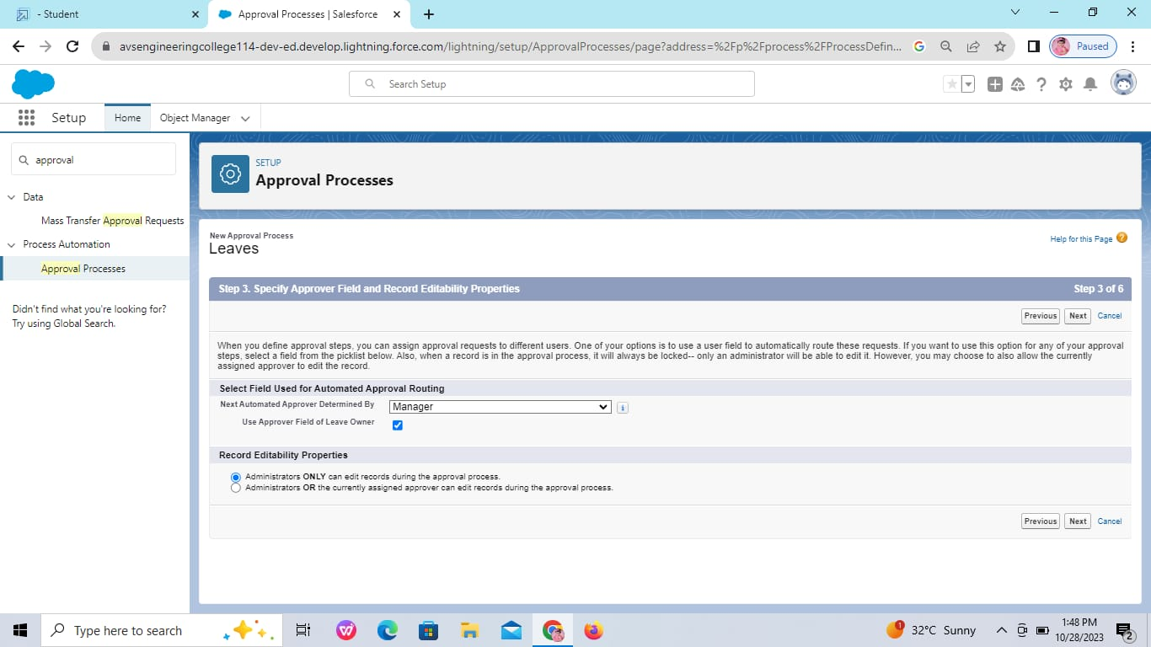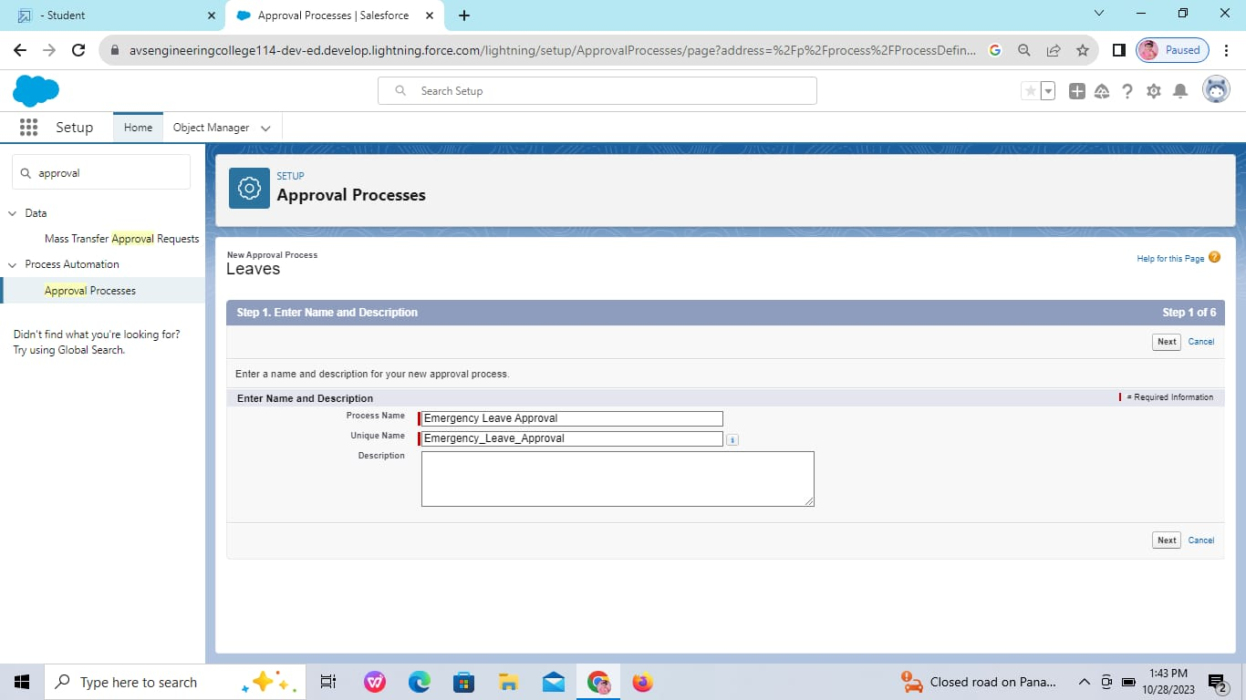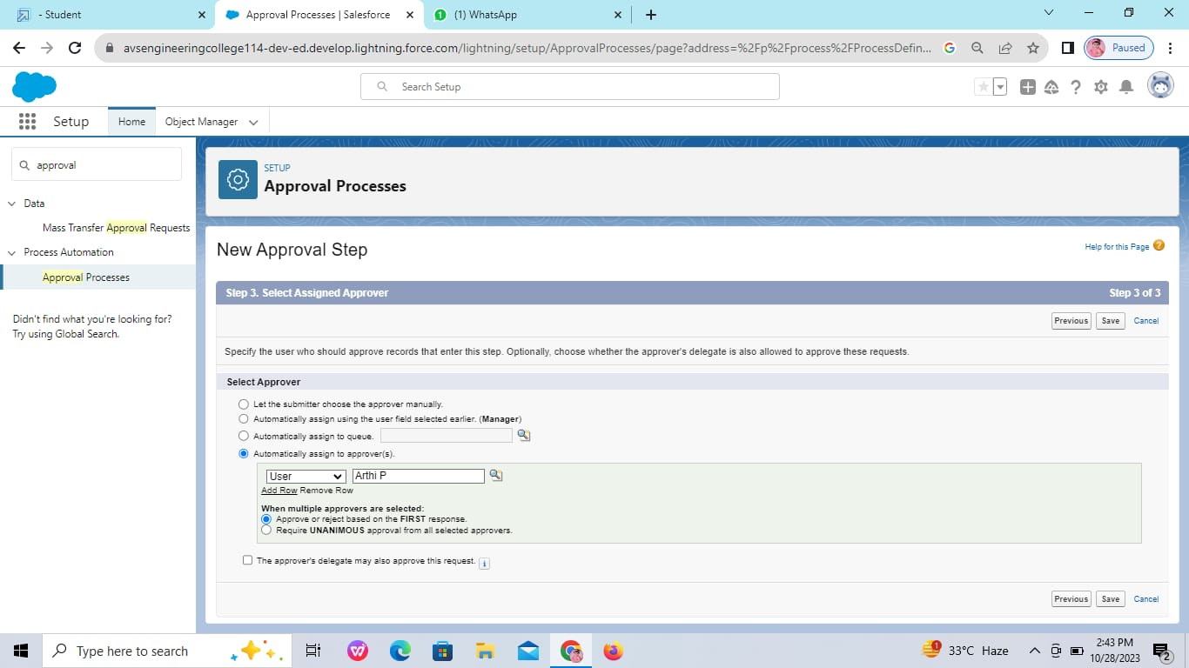

**View Record (Our Customer)**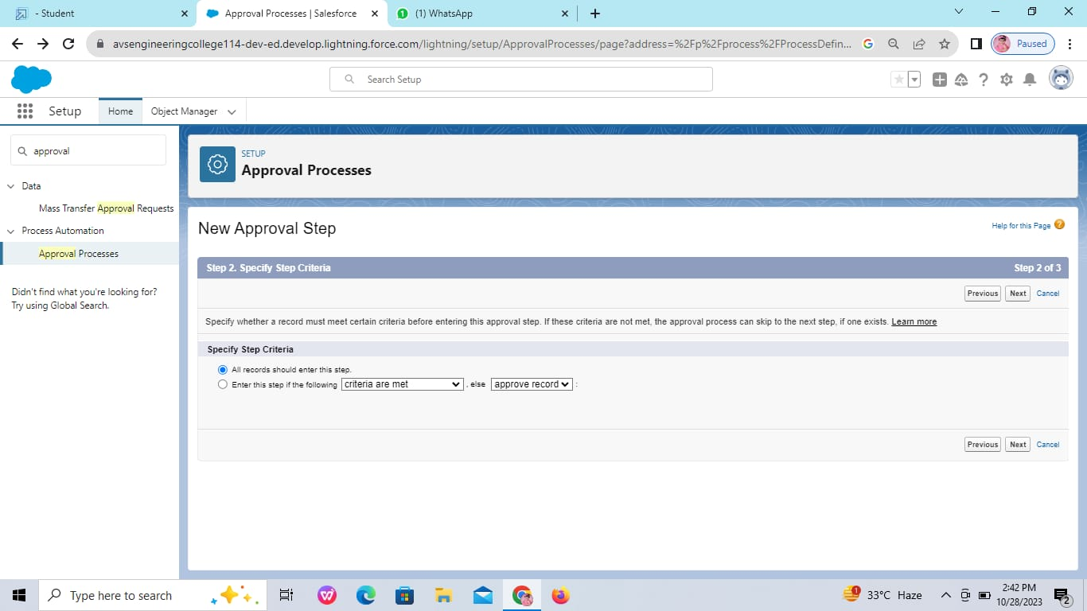

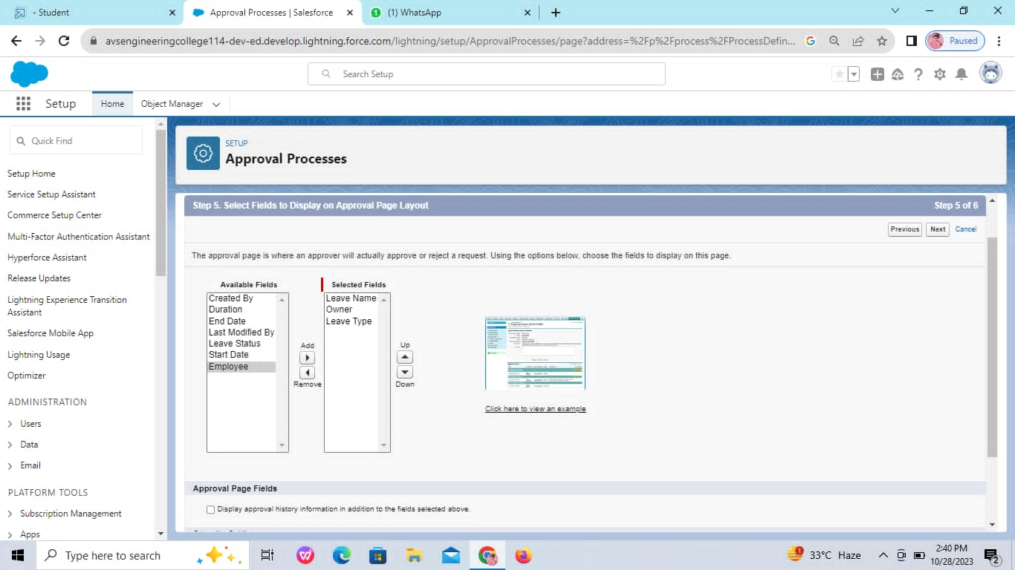

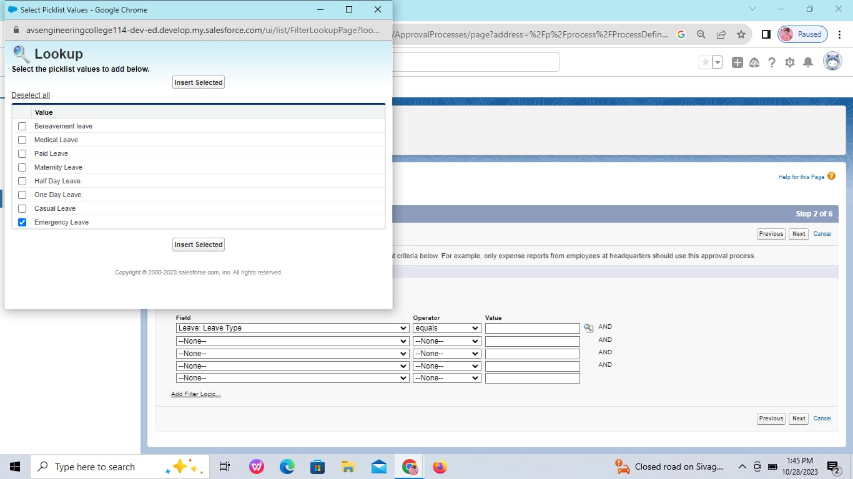

**Delete Record (Our Customer)**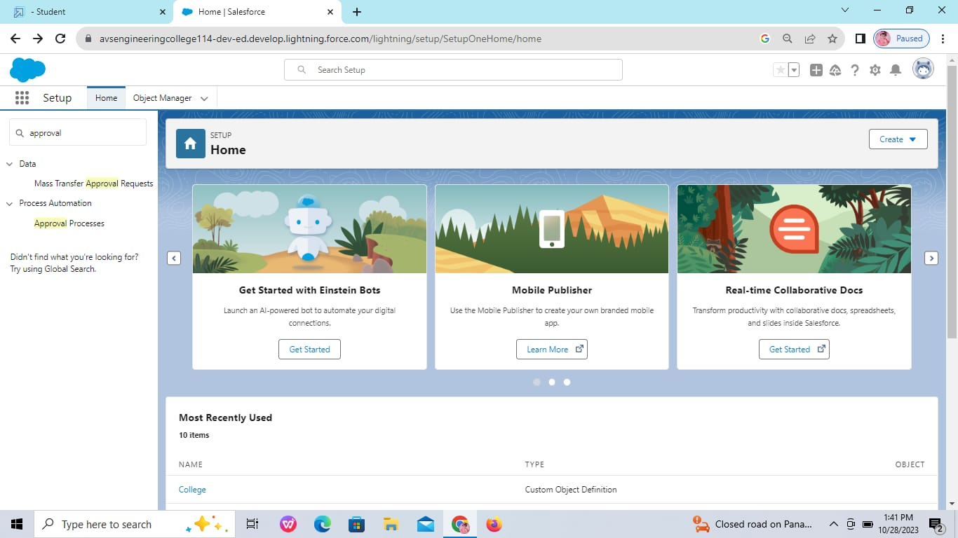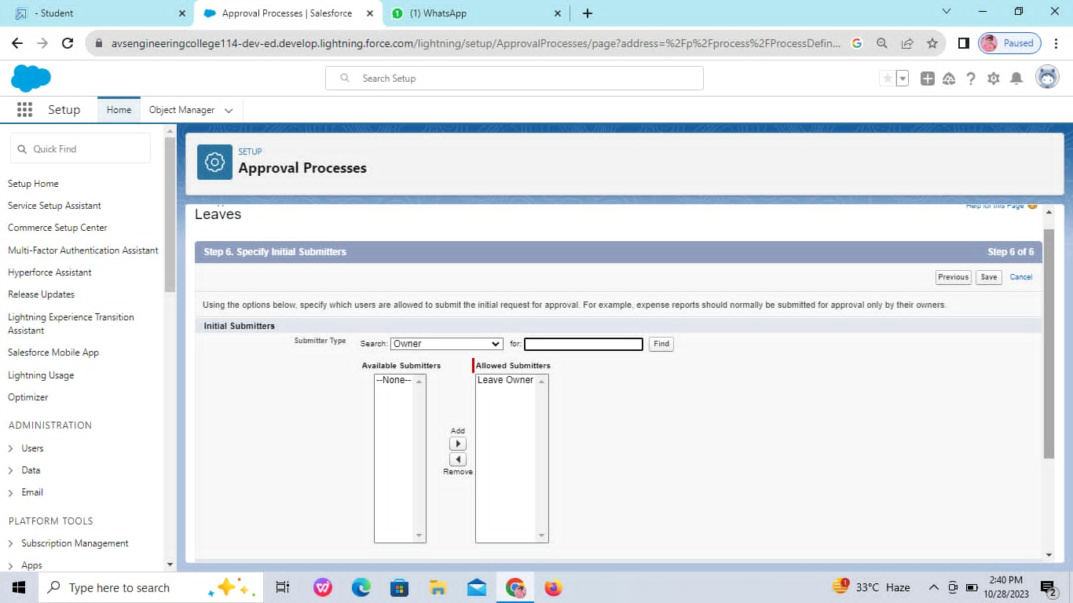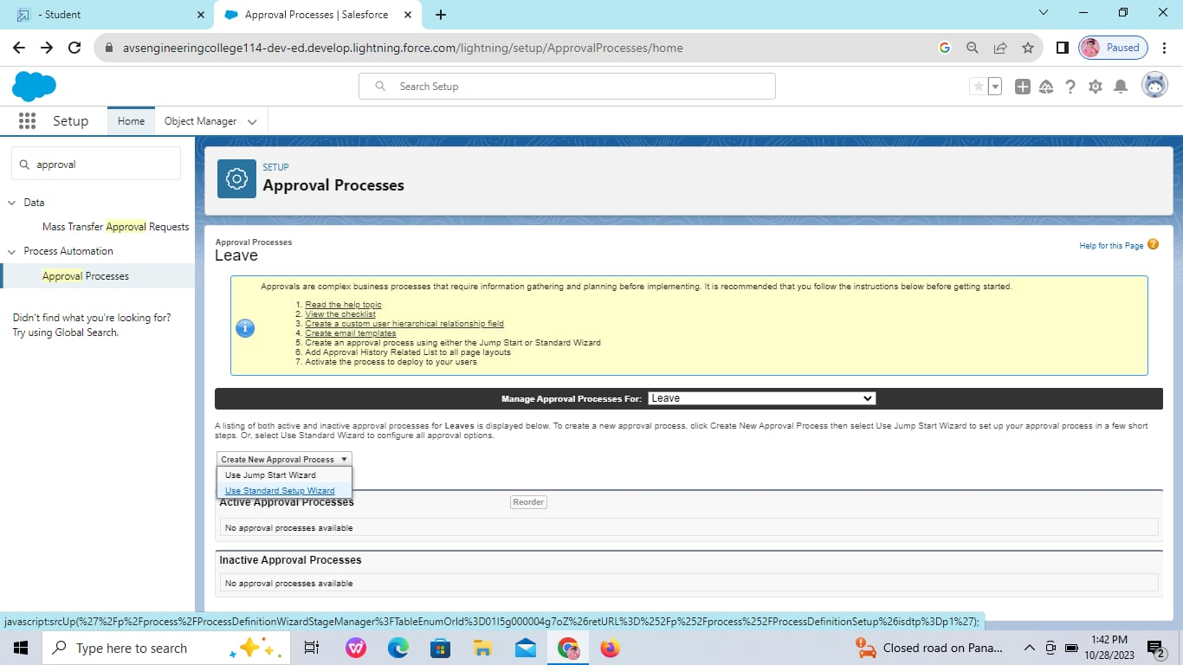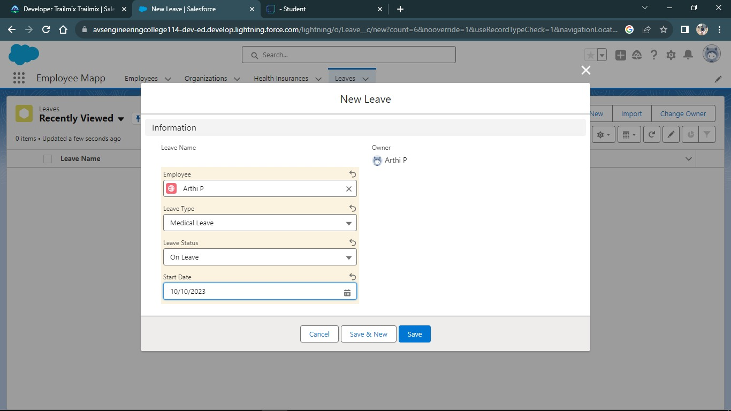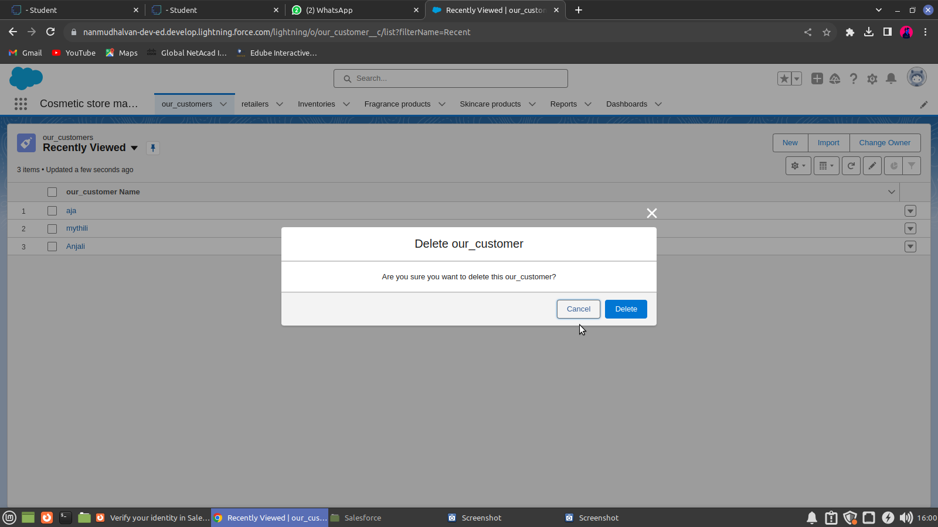

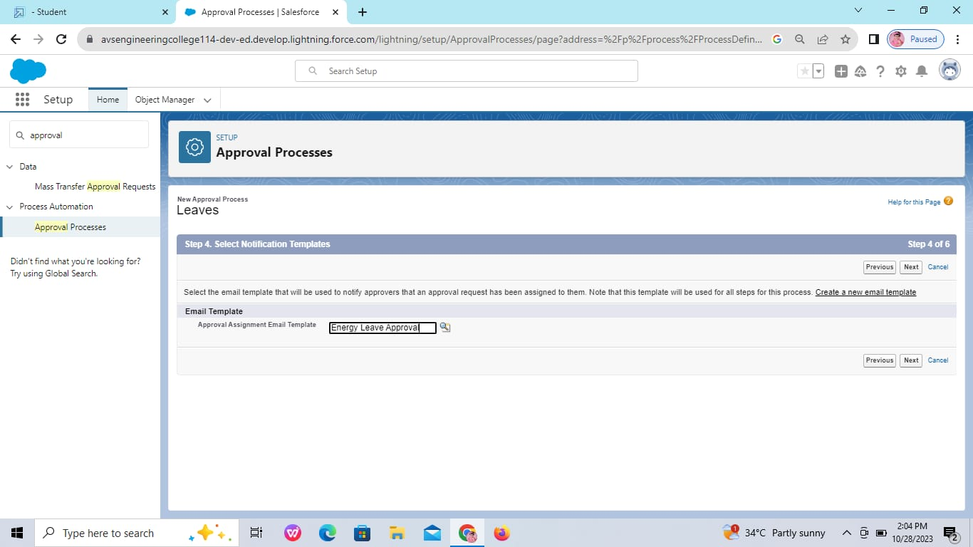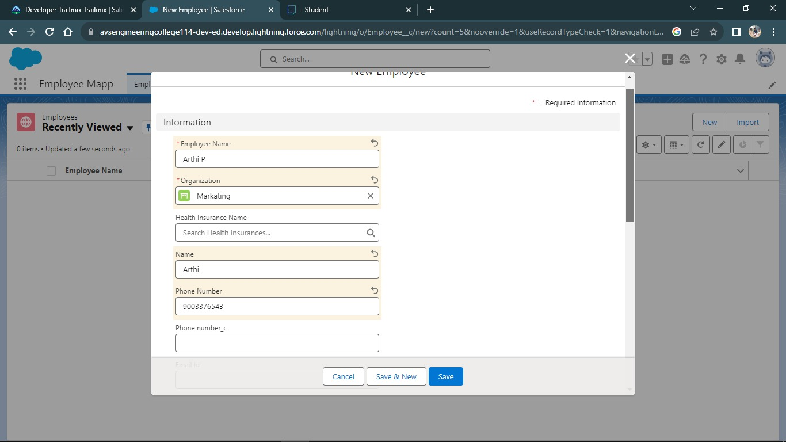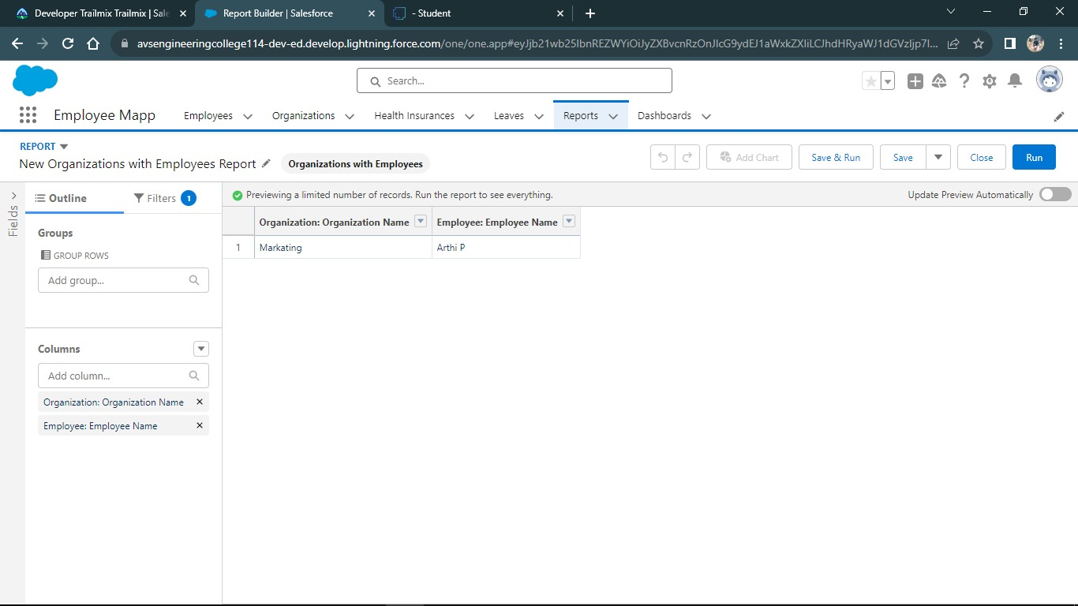

**Data Import**

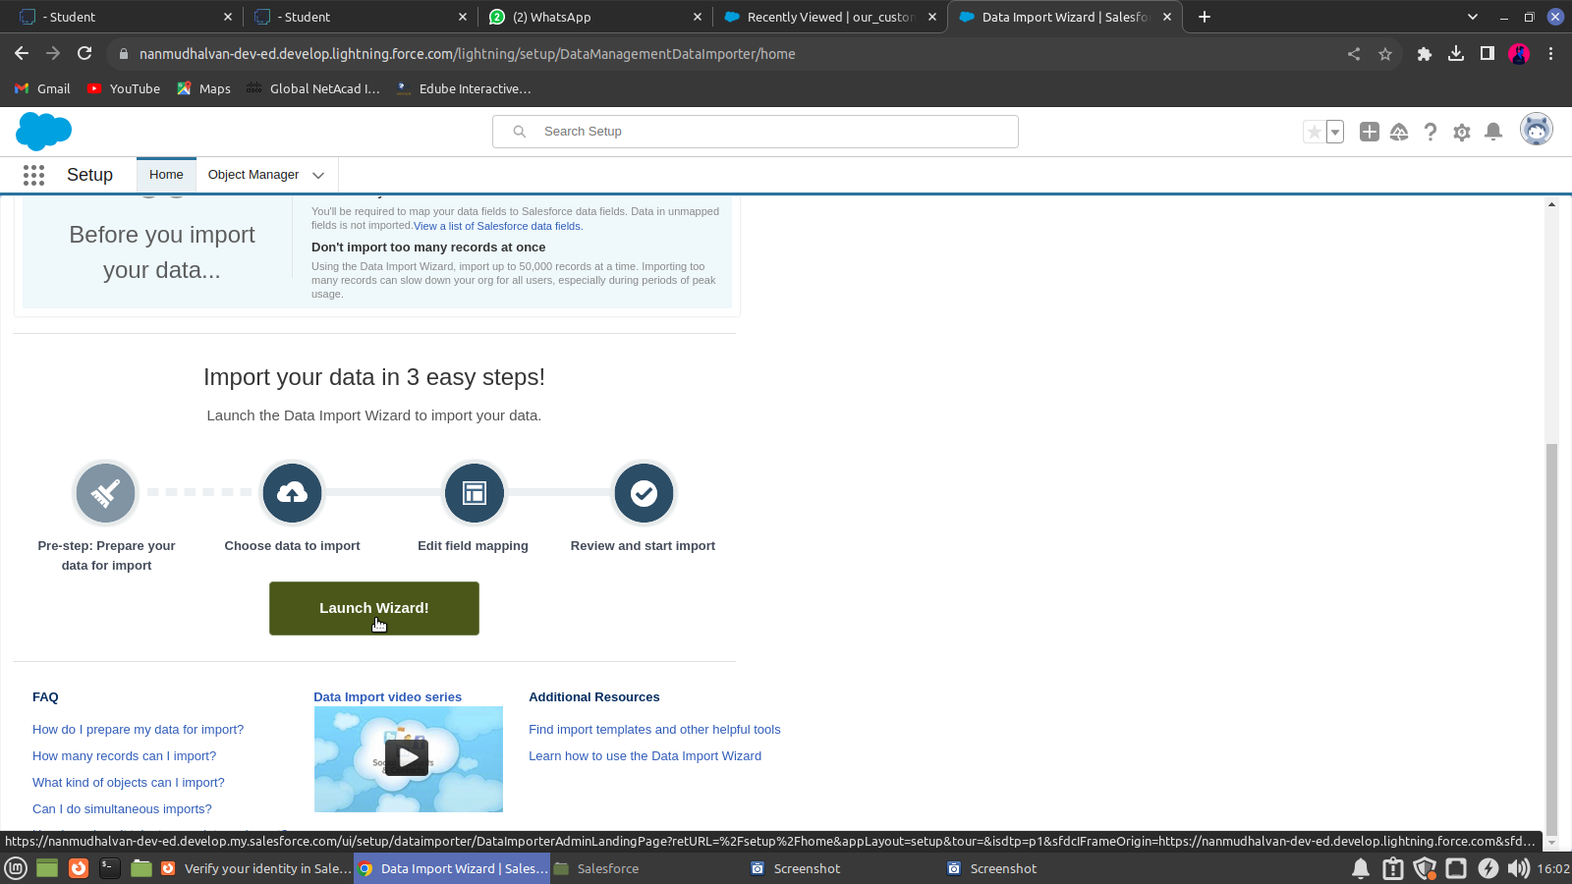The Data Import Wizard is one of various tools available to Salesforce users for importing data. The tool is best used when importing data into the Account, Contact, Lead, or Solution objects along with any custom objects within your Salesforce organization

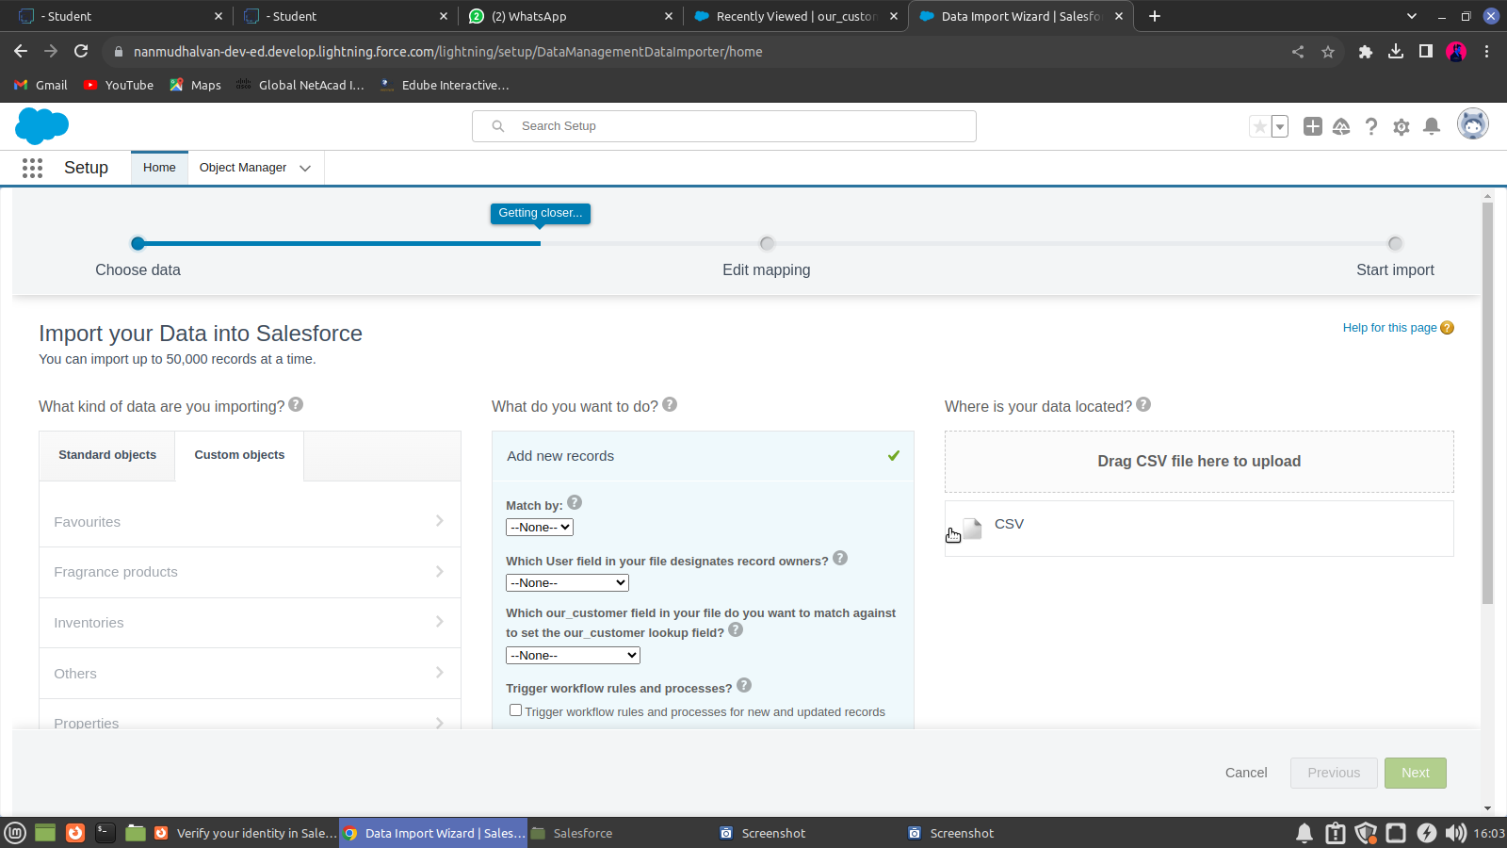

Downloading it via :  
<https://tinyurl.com/Consultantsrecords> and Accessing to local storage.

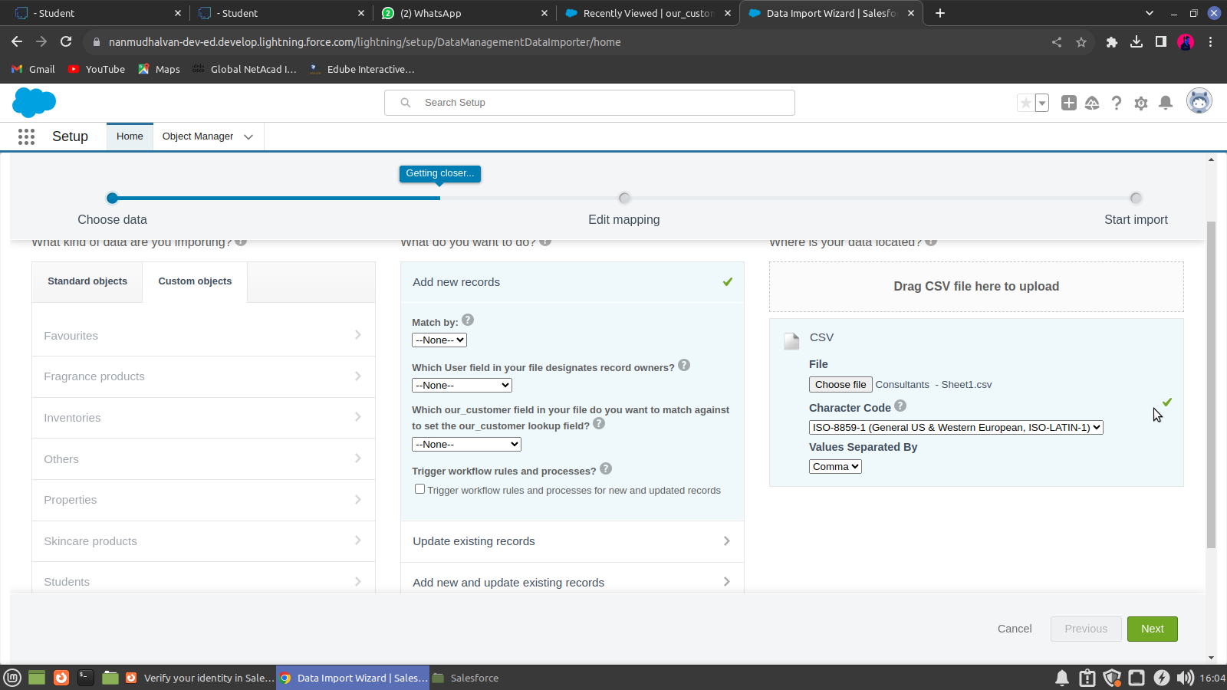

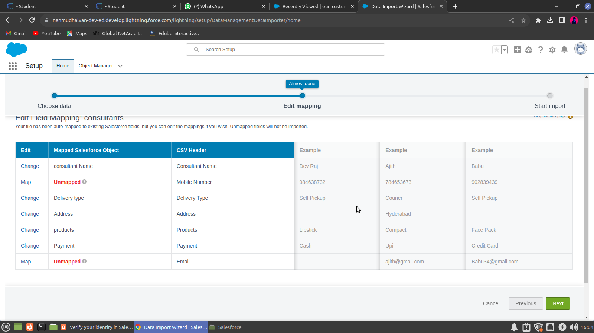

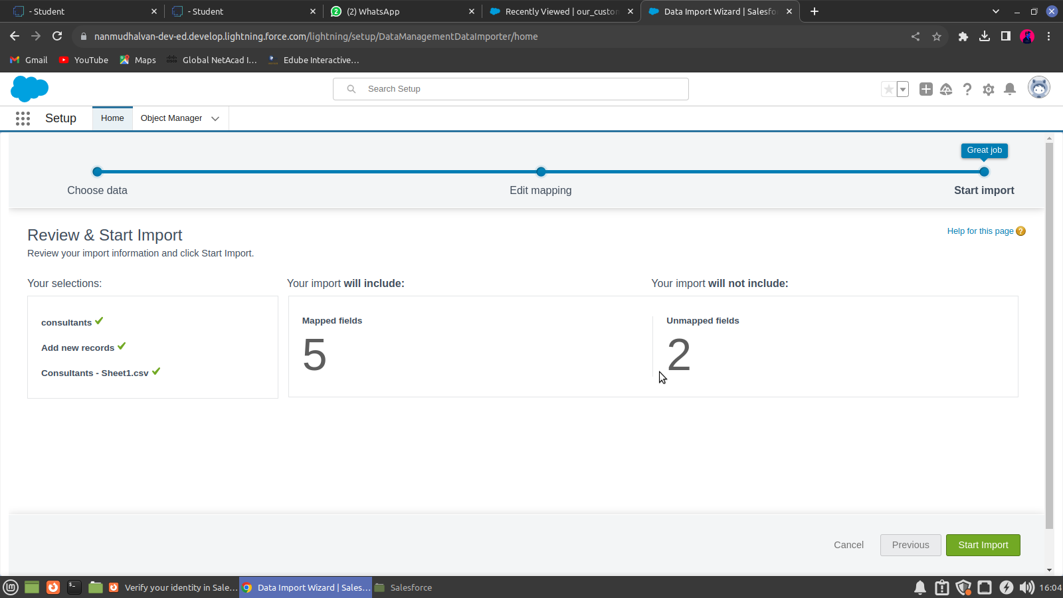

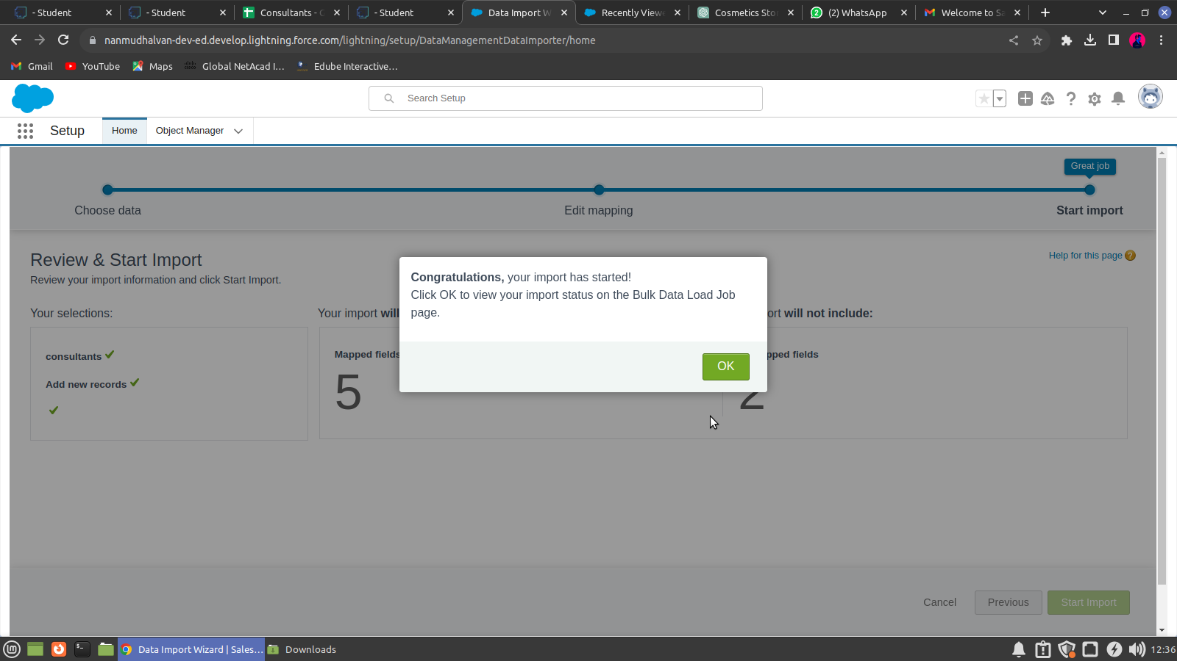

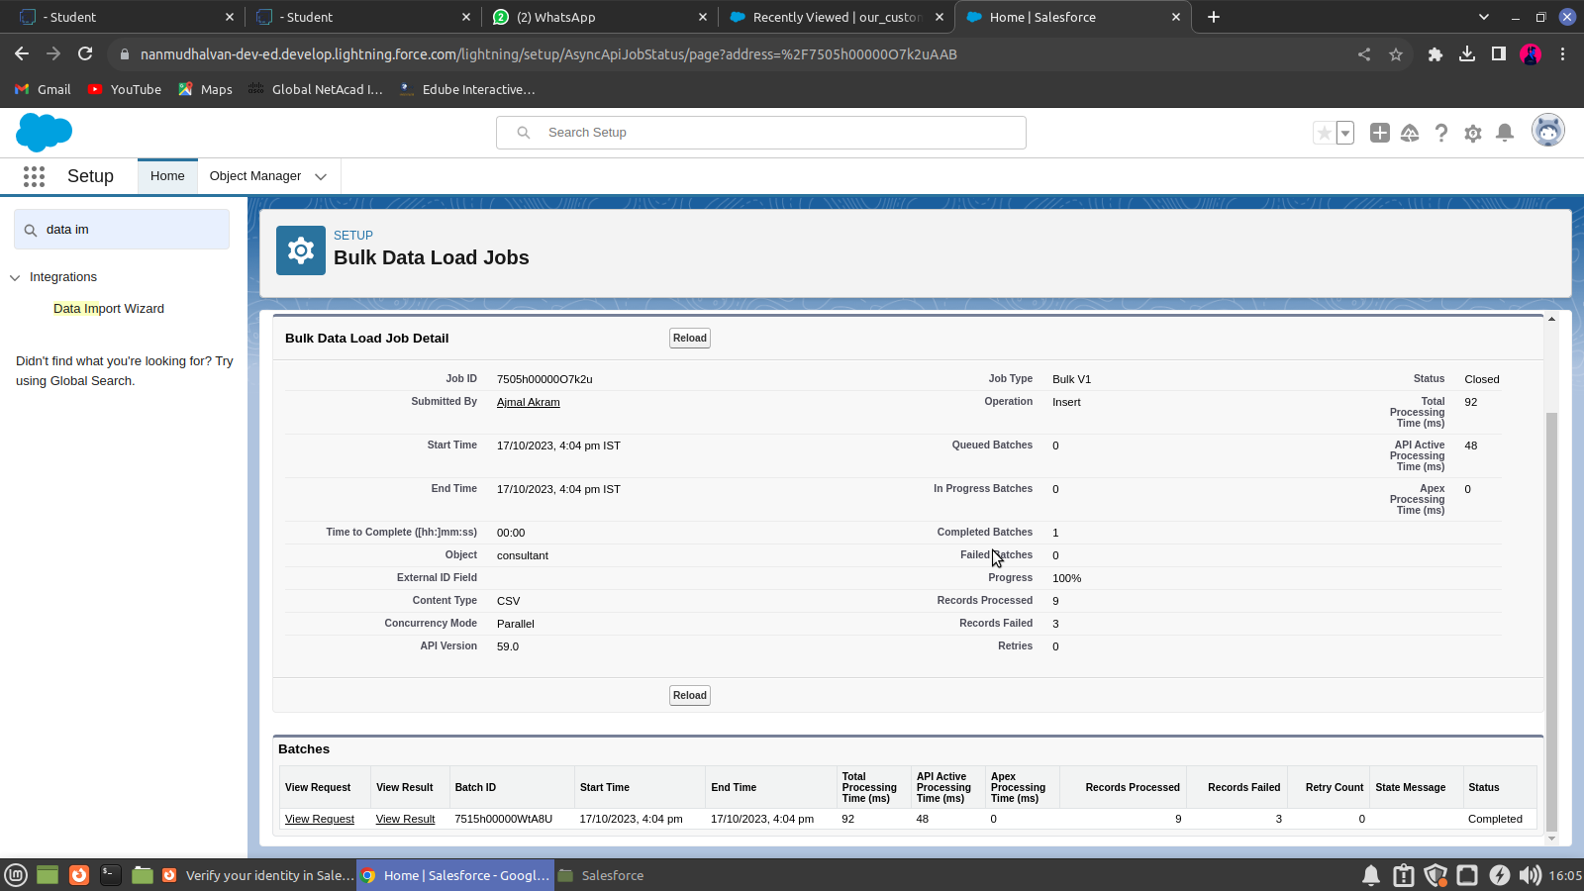

**CHAPTER-4**

**AUTOMATION**

**4.1 Flow**

The last business rule functionality to implement before testing your application is a rule to set the Out-of-State checkbox field on the Travel Approval object if out-of-andstate travel has been chosen. Salesforce offers workflow capabilities that provide a declarative, drag-and-drop design environment to build our business process logic.

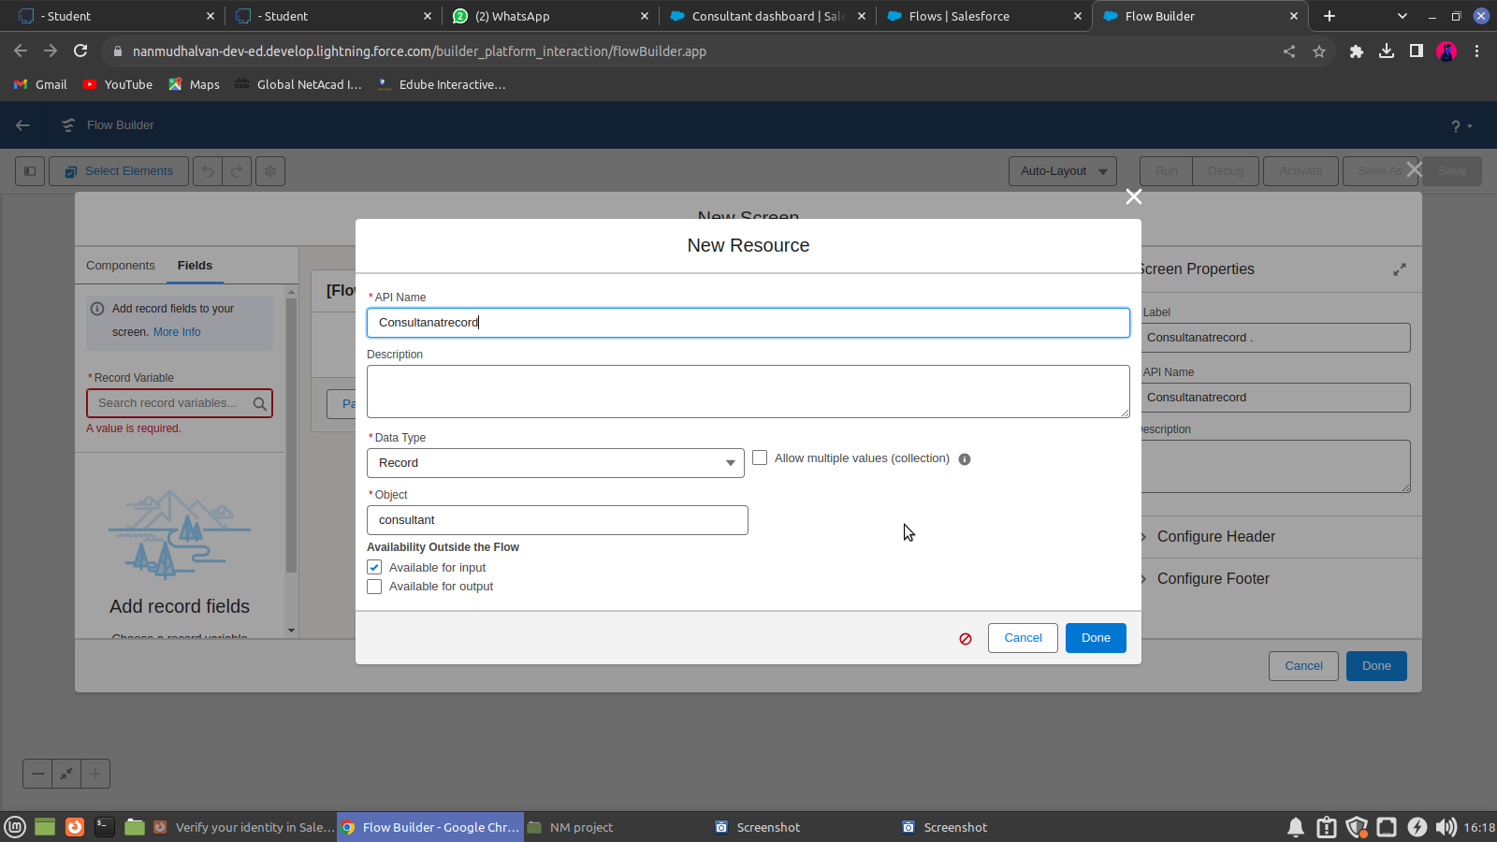

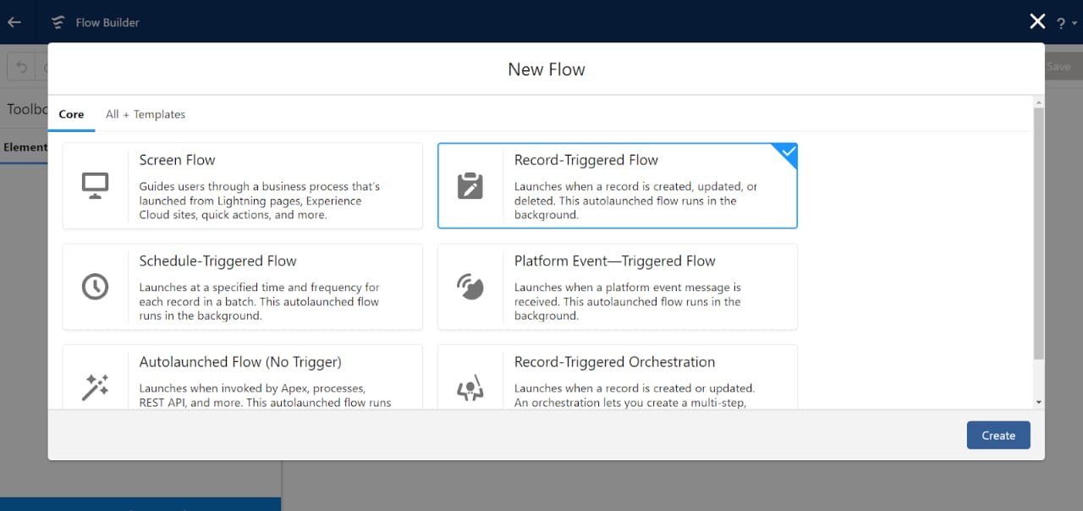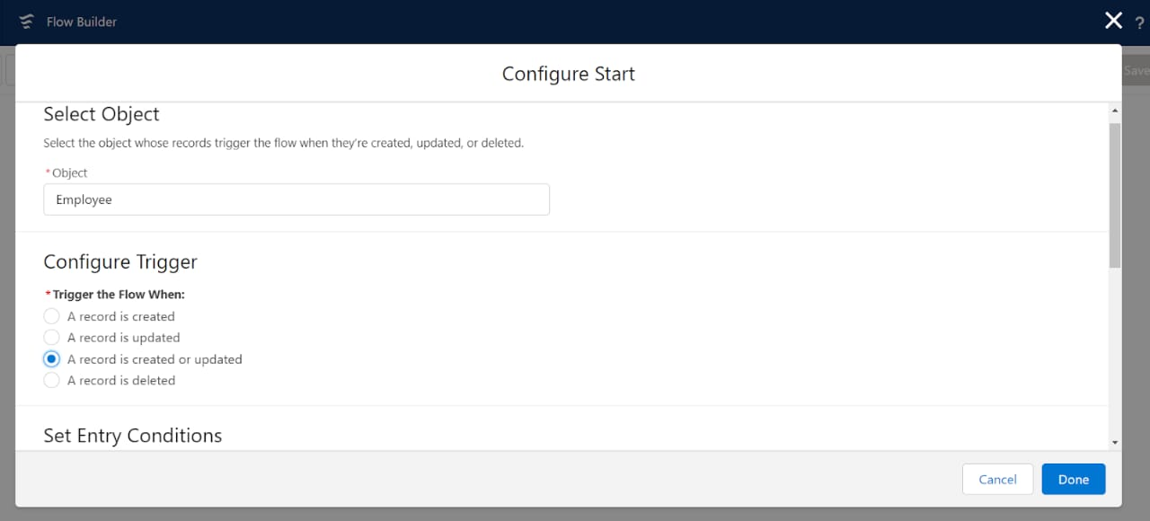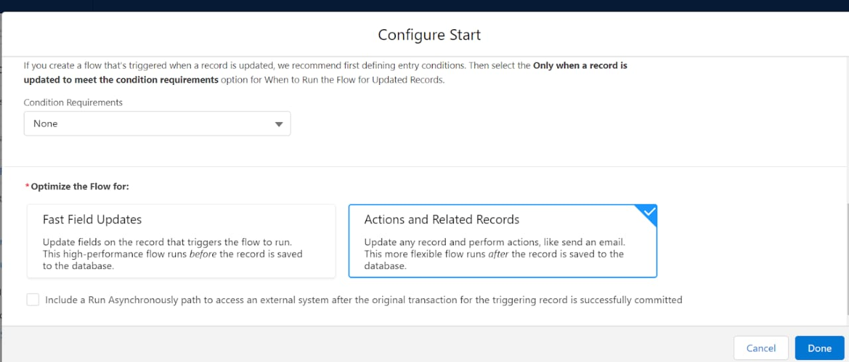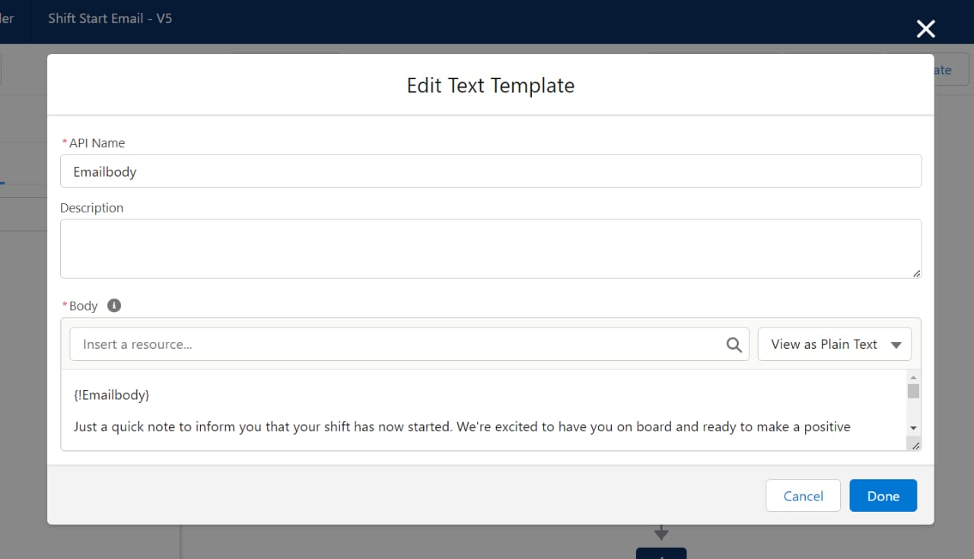

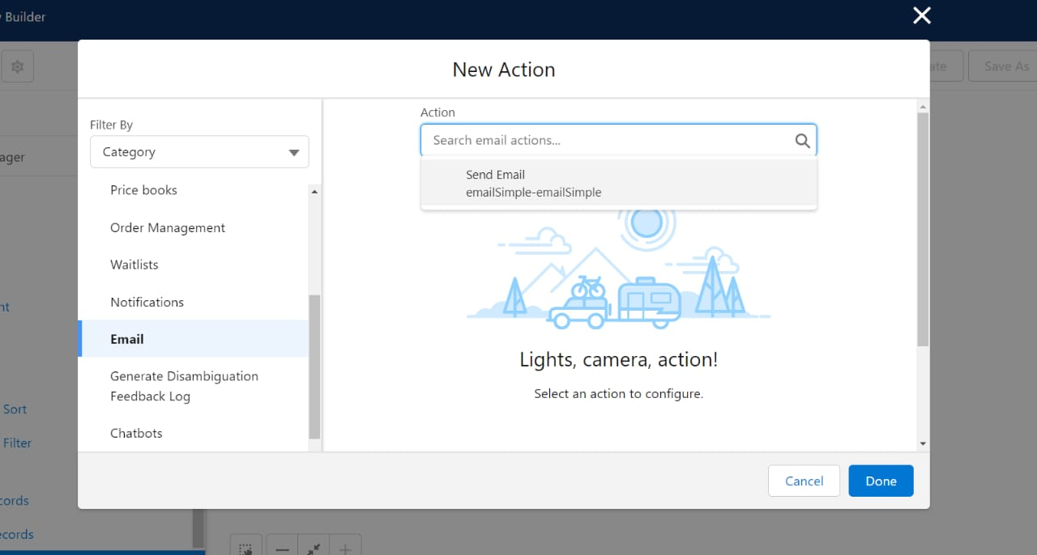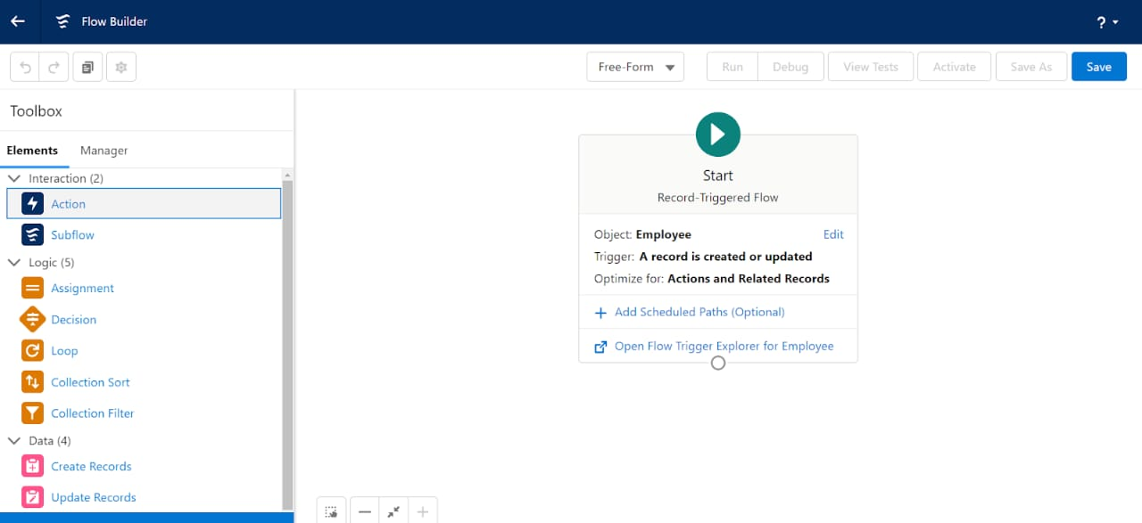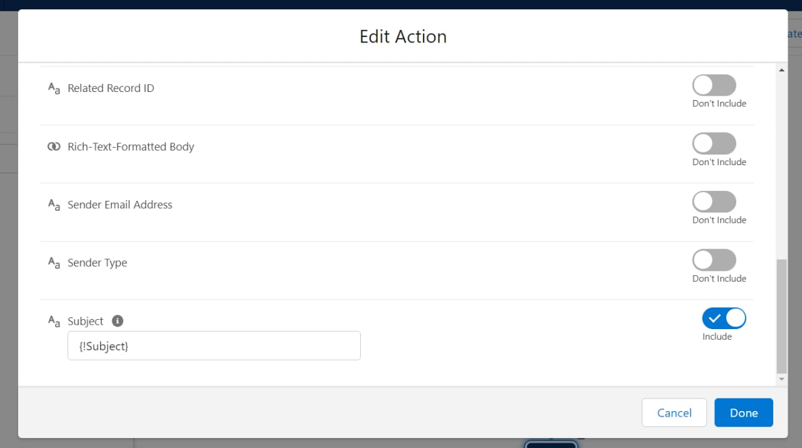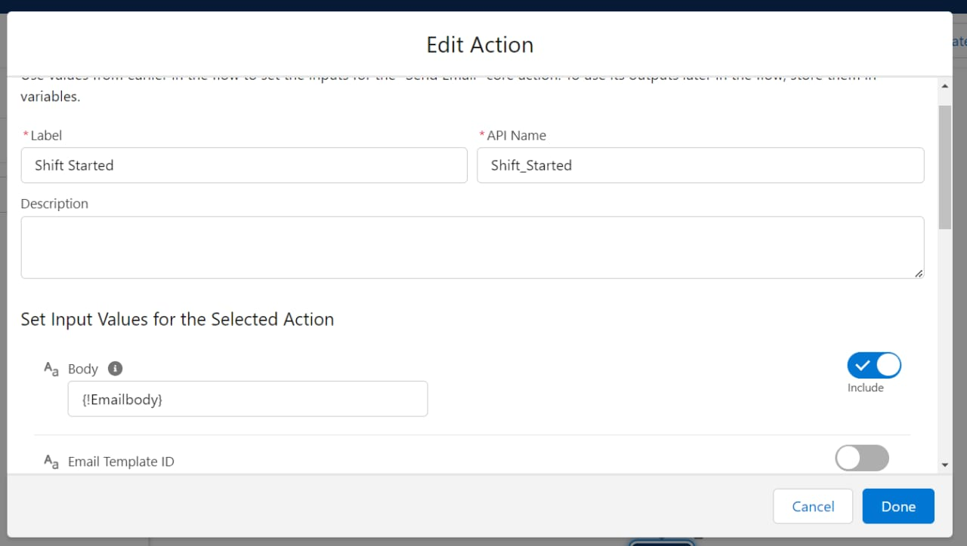

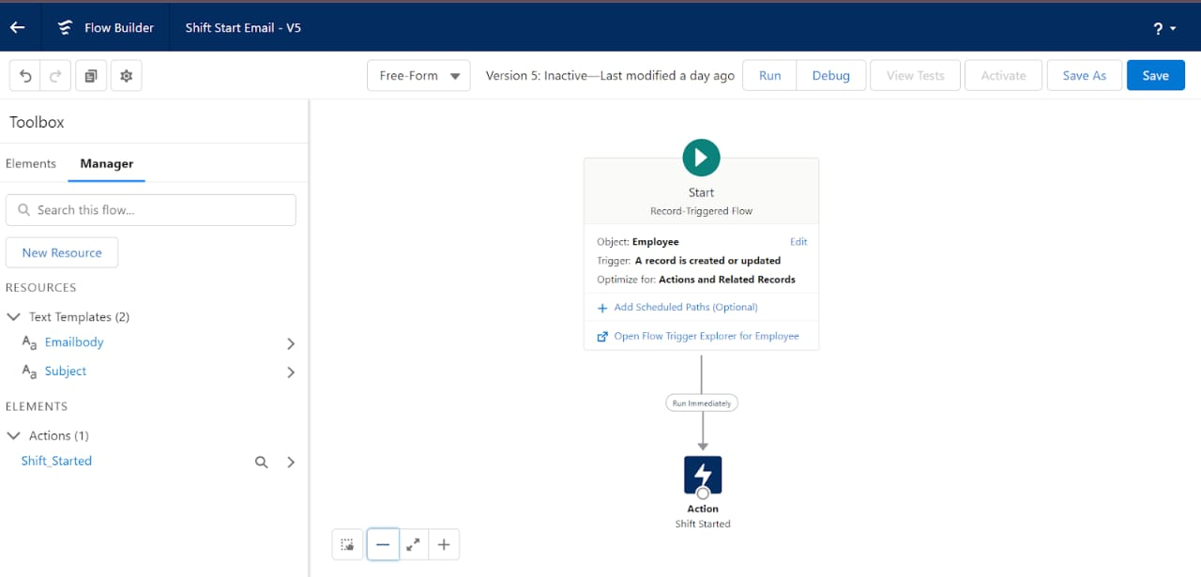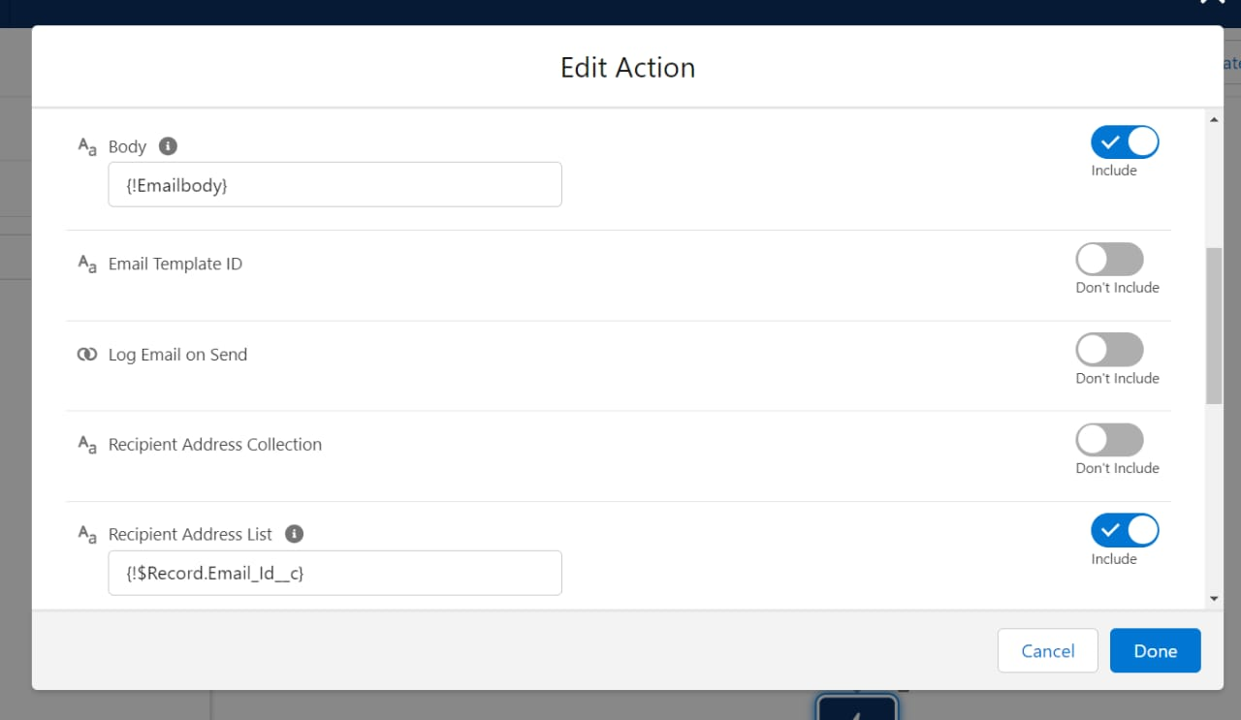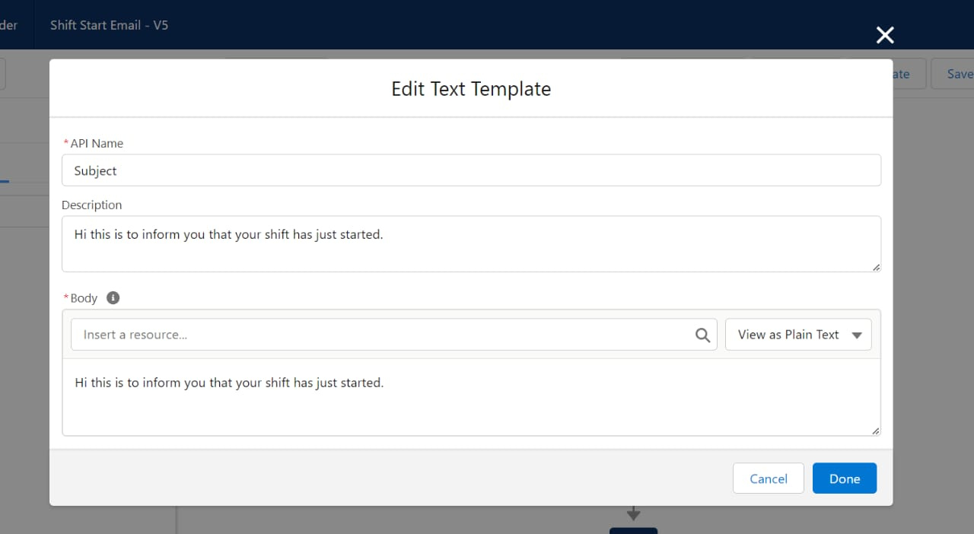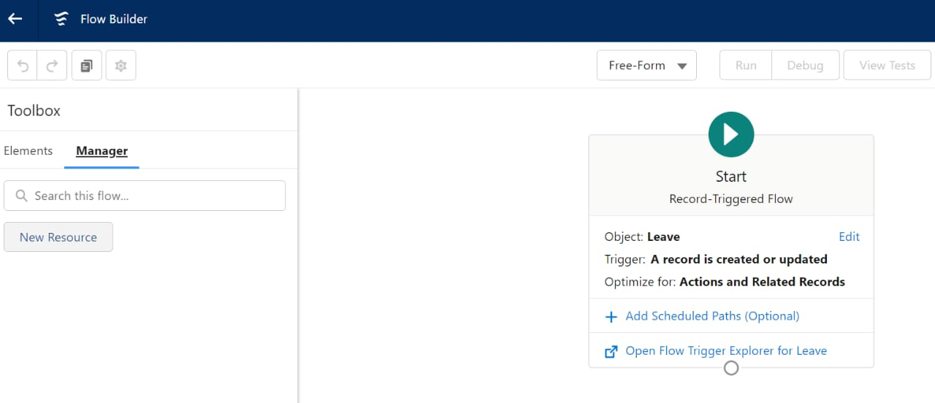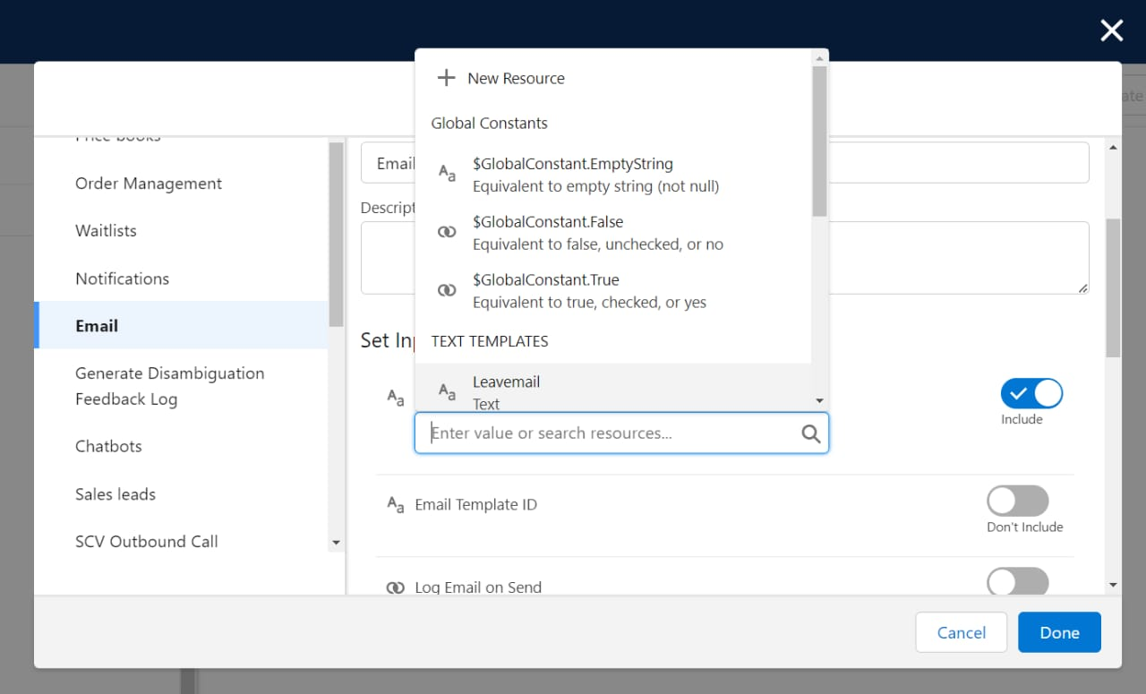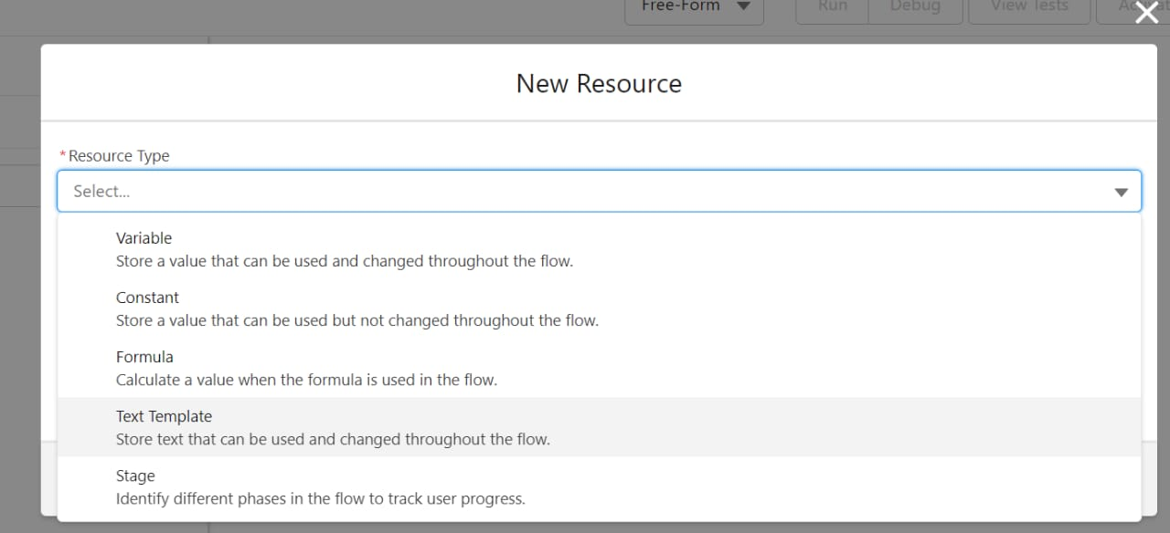

**CHAPTER-5**

**REPORTS & DASHBOARD**

**Mama5.1 Reports**

A Salesforce report is a list of data generated based on filter criteria. Salesforce Reports helped us predict trends and gives us the advantage to increase profits. The report builder provides a drag-and-drop interface to easily build and customize your reports.



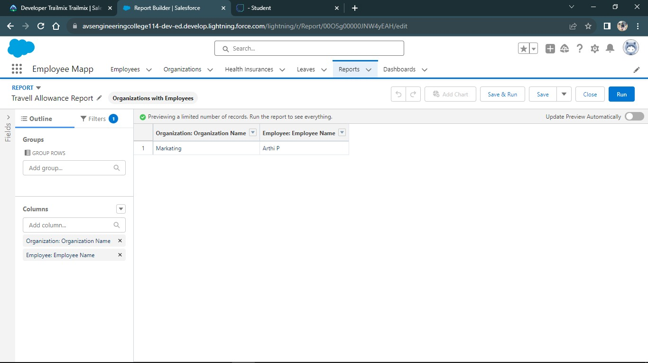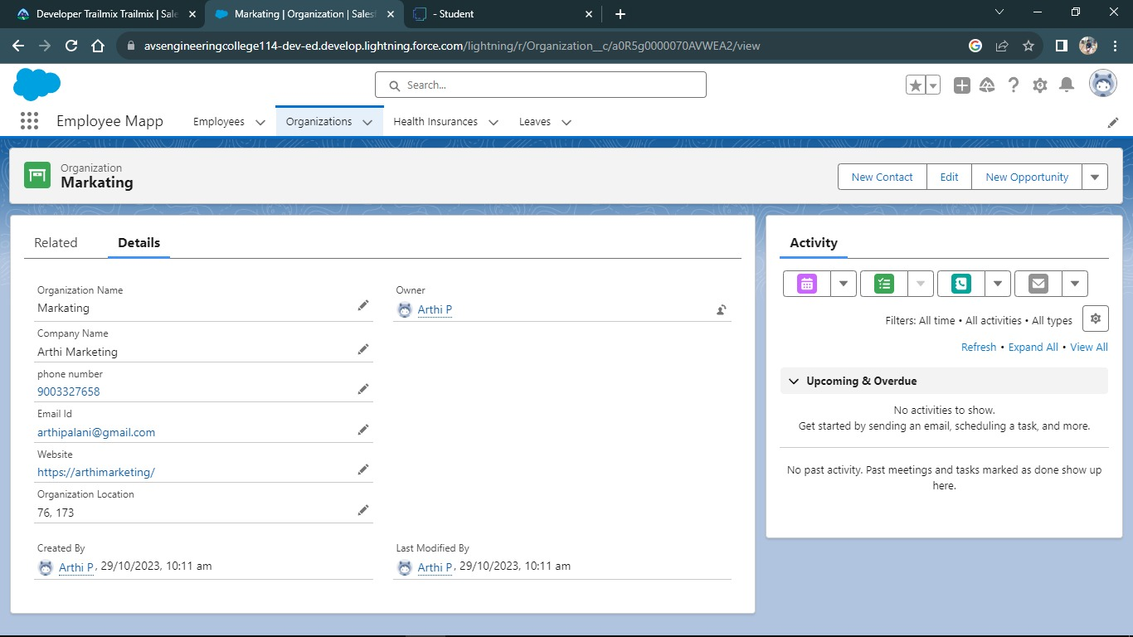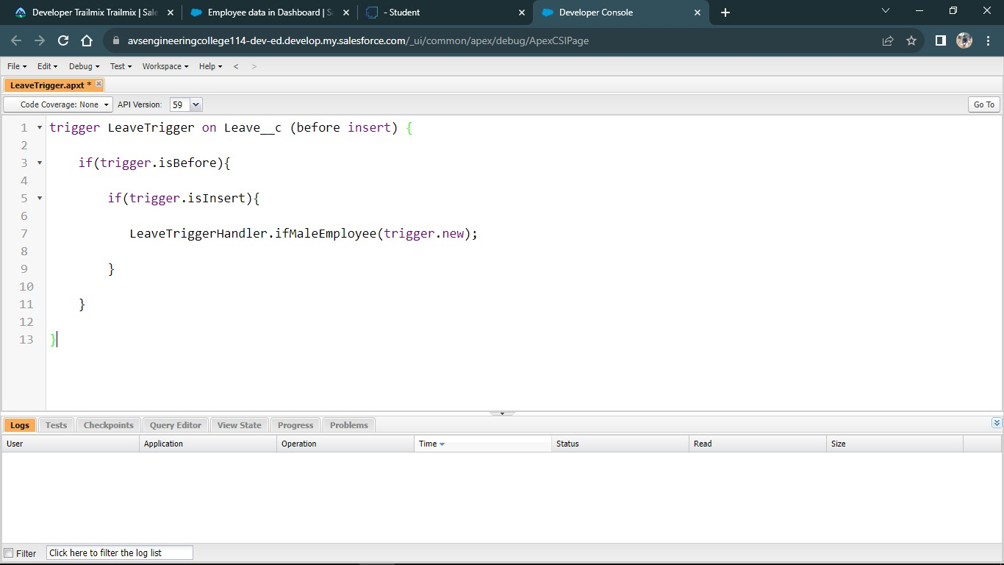

**5.2 Dashboard**

A dashboard provides an interactive visual display of key metrics and trends. Multiple dashboard components can be shown together on a single dashboard layout, creating rich visual displays of multiple reports that have a common theme.

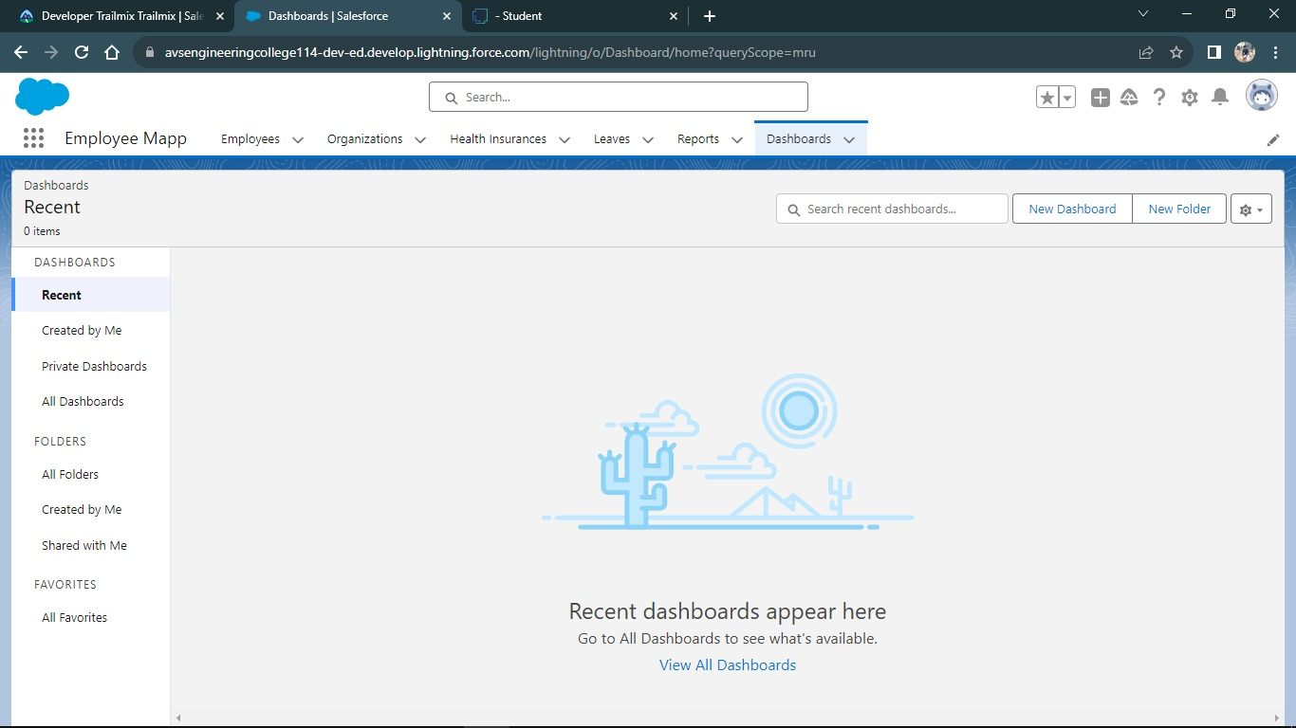

**View Dashboard**

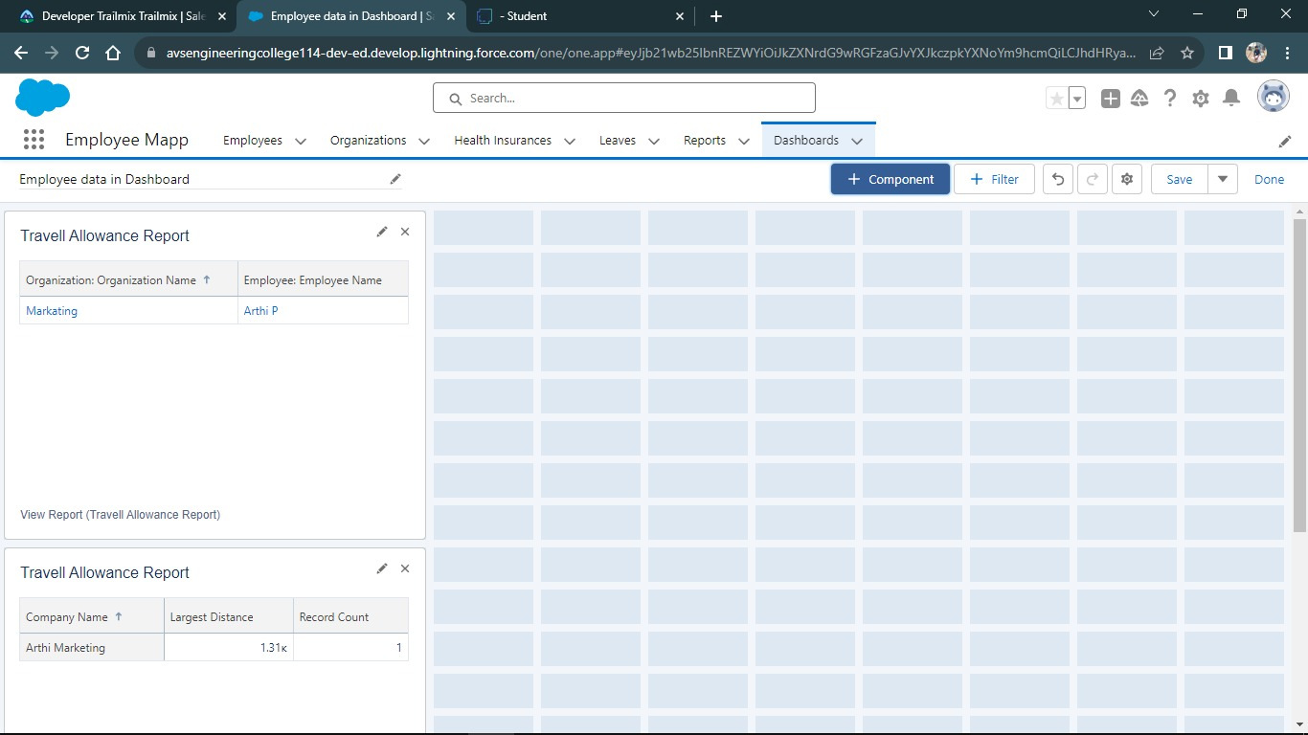

**CHAPTER-6**

**CONCLUSION**

In conclusion, the Streamlined Employee Detail Management Project has successfully modernized the way our organization manages and accesses employee data. By implementing an efficient and user-friendly system, we have not only enhanced the accuracy of employee records but also drastically reduced the time taken for data retrieval and updates. This project is a testament to the benefits of integrating technology into human resource functions, leading to optimized processes and increased productivity. As we move forward, we anticipate that the system will be an invaluable tool for both management and employees, ensuring smooth operations and effective data management.

**CHAPTER-7**

**PROJECT DEMONSTRATION**

**GitHub:**

<https://github.com/Arthi0911/Salesforce>

**Demo Link:**

<https://youtu.be/CtZ_1OEGXa0>